## INTRODUCTION

### Introduction

The COVID-19 pandemic infection has significantly changed how people interact with each other, causing individuals to consider different forms of communicating, learning, hosting special events, and interacting with friends and family. This also contributed to tremendous increases in the number of users of video conferencing. Video conferencing application is utilized in a wide range of areas, from personal user software to more specialized systems, such as apps relevant to the industry, education, and healthcare. Several specific video conferencing devices are accessible today. Zoom, Microsoft Team and Cisco Webex are examples of famous video conferencing platform. This project aims to develop a new video conferencing system to incorporate useful features from various existing systems and promote user engagement. This chapter will provide details about the general overview of the project, problem statement, objectives, proposed solution, project approach as well as the scope.

### Background of The Problem

The idea of communicating over long distances, both audibly and visually begin from audio wires in the 1870s and Bell Lab's video phone in 1927 (Wolfe,2019). In 1964, AT&T introduced the first video conferencing at the World Fair in New York (Business Matters, 2015). It was a basic device where a listener on the other side of the line could see the image and hear the voice of the caller (Janice,2017). Video conferencing turn out to be free through Internet services during the 2000s (Janice,2017). Skype was one of the first to popularize video conferencing in 2003. (Wilson,2014). The technology has transformed from hardware and application-based to cloud-based systems in the evolution of video conferencing. Now, there are companies such as Zoom, Join. Me and BlueJeans that provide cloud-based video conferencing systems that make it easier for companies and individuals across the globe to communicate with others (Business Matters, 2015).

Zoom’s founder and CEO Eric Yuan recently announced in a webinar that Zoom has seen an increase in usage after the Covid-19 pandemic has forced many enterprises and universities towards remote work and online study. Data published from Zoom’s blog (2020) reveals the number of Zoom users in March 2020 grew to 200 million from around 10 million three months ago. According to UC Today, video conferencing app Webex hosted over 20 billion meeting minutes this April 2020, double February's count (Beufor,2020). Google Meet added three million new users last month, and since the beginning of the year, the average number of people in video calls has risen by five. (Peters, 2020).

When technology evolves, the way we learn, interact and work also change. Many organizations, as well as individuals, utilize video conferencing to communicate with others, boost work productivity, facilitate telecommuting, and more. However, organisations and individuals have still encountered some issues when using the existing online video conferencing system to set up a virtual meeting.

### Problem Statement

The current problems in a video conferencing system can be divided into two main areas. For the problem statements identified below, the first and second statements address the problems in the existing video conferencing system. The last problem statement, on the other hand, addresses the shortcoming of using the video conferencing system.

#### Lack of Personal Interaction and Engagement

Most meetings involve personal interaction. Unlike traditional face-to-face conferences, online video conferencing does not allow direct interaction between the participants. 90% of people daydreaming in meetings, according to Dr Donald Wetmore (2018), founder of the Productivity Institute. Nevertheless, virtual meetings are often more difficult because of people more likely to get bored, multitasking, and many other disruptions. According to The Muse (2020), Majority of employees surveyed reported multitasking at meetings, while two-third of the employees reviewed their email during meetings. Hence, making a virtual meeting interesting with lively engagement is necessary to keep everyone's attention in the meeting.

#### Lack of Built-In Speed Test to Detect Network Connectivity

A good quality video conferencing requires fast network connections. Inadequate bandwidth and network connectivity issues affect user experience. The common problems faced by users are delay, a freezing computer, bad audio quality or disconnected, screen sharing failure and extended, unexplained delays (Bell, 2020). A research in 2014 German (Schoenenberg et al., 2014) found that delays in a virtual meeting had a negative influence on the participants: delays of only 1.2 seconds will make people feel the person presenting is less polite or not concentrated. Although silence is a common part of the discussion in real life, it can appear uncomfortable in video conferencing, or trigger us to worry that others cannot hear our voice. Hence it is essential to provide a speed test to detect the participants' network connectivity. However, the existing video conferencing system does not have a built-in speed test, and the participant can only use a third-party device to verify the speed of the internet connection.

#### Low Productivity of Video Conferencing

Look Up Research Now (2018) questioned enterprise employees about their conference call experiences. The study showed that an average conference call lasting around 38 minutes with a total of 15 minutes were wasted. The time wasted on a regular conference call mostly because of failing to start the meeting on time, addressing conference infrastructure problems and dealing with disruptions. Data indicates that 85.3% of respondents noticed the negative effect of disruptions on conference calls, including in meeting productivity, becoming able to progress into an agenda, being passionate or being able to stay focused. Besides, the research found that only 53% of respondents found video conferencing to be effective for everyday meetings. More than 63% of participants mentioned that they must wait for more than five minutes to get everyone to set up on online conference devices until the meeting could start properly.

### Project Objectives

Main objective:

To implement a new web-based video conferencing system that delivers enhanced engagement for team collaboration and productivity using Prototyping approach in 24 weeks.

Sub-objectives:

1. To analyze project requirements and existing similar video conferencing system during Project 1 period.
2. To design a model of web-based video conferencing system during Project 1 period.
3. To develop a new web-based video conferencing system with collaboration tools to promote user engagement using Prototyping approach.
4. To evaluate the functionalities of the applications by using functional testing and user acceptance testing results during Project 2 period.

### Proposed Solution

#### Front-End Development

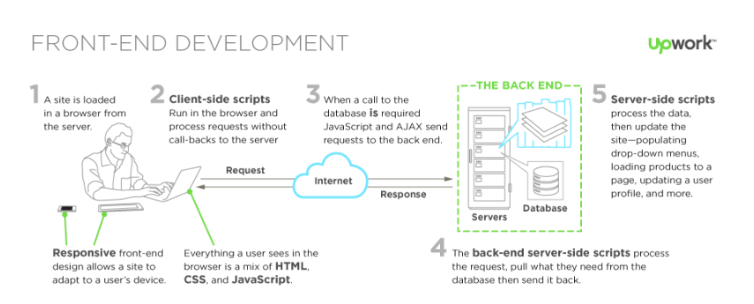

Figure 1.1: Front-End Development (Wodehouse, 2020)

According to Sagara Idea Lab (2019), front-end development is referred to as the "client-side" programming, is all about the UI and UX. UI is the abbreviation of the "user interface" while UX refers to the term "user experience". While design a software application, UI designs come in the first place. Design and interaction are strongly tied to the interfaces. It is important in supporting software functions visually. The UI is about icons and buttons, links, typography and colour schemes, layout, images, and responsive design (Lamprecht, 2019).

Unlike UI design is about visuals, the UX emphases on the overall feel of the experience. It emphasizes on software usability, functionality and features, user satisfaction, and stakeholder value (Joo,2017). The "Eight Golden Rules of Interface Design" from Shneiderman is being used as a guide to enhance user interface design and improve user experience. HTML as the organizer, JavaScript as the multitasker and CSS as the stylist are some of the key technologies used in front-end web development (Sagara Idea Lab, 2019).

#### Back-End Development

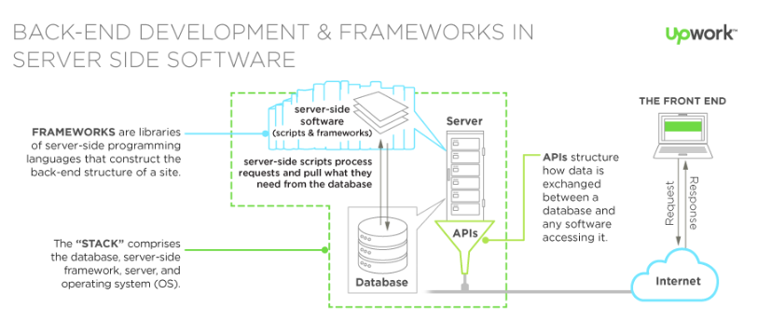

Figure 1.2: Back-End Development (Wodehouse, 2020)

Sagara Idea Lab (2019) clarified that the backend, also known as "server-side" programming, is the mechanism that operates behind the scenes to assist consumers communicating with the applications on the client-side. The major back-end components are a server as a machine, middleware as plumbing, programming languages and framework as nuts and bolts, and a database as a brain (Wodehouse,2020). Back-end development is important to make these components communicate with each other. It involves writing APIs, writing code to connect with a database, designing databases, and system infrastructure, and more. Krystal Tolani (2020) from GoSkills shares the various types of backend languages used by backend developers: Java, Python, Ruby, SQL, Javascript, .Net and PHP.

#### Video Streaming Protocol Integration

Max Wilbert (2020) described a video streaming protocol as a structured distribution technique for splitting up, distributing, and reconstructing a video into chunks. In other words, a streaming protocol is to deliver data over the internet. Some protocols prioritize minimizing latency, some operate exclusively on certain devices and some emphasis on digital rights management (DRM), Wilbert added. In this project, the WebRTC (Real-Time Communication) protocol is used. It allows the transmission of a live video or audio through the application (Ruther,2019). WebRTC is a secure protocol and it offers features, such as peering, streaming, audio or video codecs for communication between users (Oleksandr et al., 2020).

### Proposed Approach

There are a lot of methodologies for software development or Software Development Life Cycle (SDLC) models that can be used in a software project. Each of these methodologies has its pros and cons. The methodology is chosen to match the specific requirements and characteristics of a project. In this case, the methodology to be used in this project is the prototyping methodology as show in Figure 1.3.

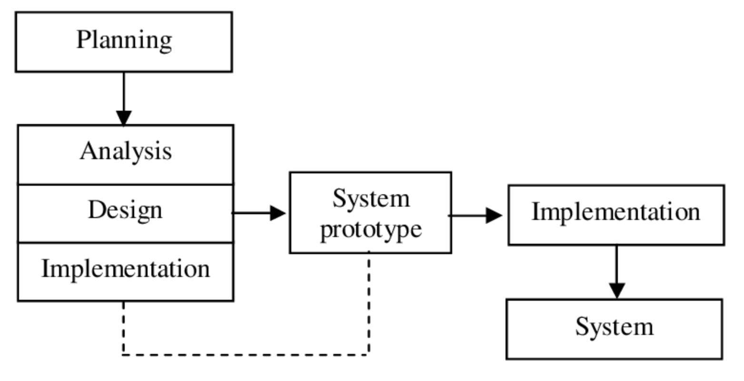

Figure 1.3: Prototyping Methodology (Wahab, 2009)

At the planning stage, develop a system request and conduct a feasibility analysis about a video conferencing system. Establish milestone, purpose, problem statement, objective and target user. A Gantt Chart is used to shows the project tasks to be done with the start and end date. At the analysis phase, study book, research papers, journals and articles about the video conferencing system, communication technology and related project. Then, write a comprehensive summary of the research. Besides, analyse existing similar systems to define potential features of these systems to integrate certain features into the proposed system and design a more reliable system. Review the latest trends of the video conferencing system. Gather functional and non-functional requirements.

The design phase involves creating a use case diagram, design plan, planning the layout and user interfaces, determining the features of the system and design the data model. Identify the inputs and the expected output. Determine overall visual feels, identify colours and fonts used in the user interface. At the implementation phase, develop the first prototype and evaluate the prototype by showing the prototype to the users. The users will test the first prototype and provide feedback or comments. The feedbacks and suggestions are recorded and incorporated into the second iteration. Then re-analyse, re-design and re-implement the second prototype. The process keeps going until the final prototype meets the user requirements and provides enough functionality. Finally, implement a complete video conferencing system that contains the user interface, back-end development and database management system.

### Scope

#### Target User

The primary target user is business, companies, enterprise. This system serves customers of all sizes, from sole businesses to organizations. The second target user is universities and colleges and the system will be used for education purpose. In this project, the video conferencing system will be created on the web platform. The video conferencing mobile app will enable individuals to virtually interact with each other.

#### Basic Features

1. Registration and Sign in

The user may join a meeting without registration if he receives an invitation code for a meeting. However, if the user needs to use the conferencing system constantly, then he may sign up for a free account using email and phone number to prevent unregistered attendees from joining a meeting.

1. Profile Management and Settings

Registered users need to manage their profile like upload a profile photo and change the current password. They can also set their preference like turn on the notification when receiving a new message and turn the status visible to another user.

1. Contact List

The contact list is provided to enable the user to contact another user. Users should be able to find other people by using a search engine in the contact list. The user can add a new contact by entering a phone or email.

1. Audio and Voice Calls

Users should be able to make an audio call, a video call or set up a video conferencing. The meeting can be broadcast over the internet in real-time, and two-way audio and video allow quick communication between the attendees. Users can hold one-on-one meetings or host a meeting with several members.

1. Text messaging

When the users are in a poorly Internet covered area, or busy on a meeting, they cannot make a voice call or video call. Thus, the system must allow the user to send text messages to another person in his contact list.

1. Notification

The app will automatically notify users about new messages in the chat, missed calls, keep them informed about new updates, and more.

1. Screen Sharing

The presenter can share his/her screen for PowerPoint presentation, Word document, video and images. Screen sharing allows other meeting participants to better understand what the presenter conveys.

1. Schedule Meeting

The user can create a schedule for the meeting to plan the meeting around their calendars.

#### Advance Features

1. Rewarding Feature

The rewarding feature is implemented into a virtual meeting to help boost employee engagement and drive productivity. The user can earn points for attendance or being the first person to check in to a meeting.

1. Agenda Planner

The agenda planner can help the host to plan the agenda carefully and share it in advance. The host may share the agenda ahead of time to those who will participate so that everyone can prepare their part before the meeting. The agenda planner helps the user to design the meeting session, step by step and assigning time to each session and remind the participants of the meeting goal during a meeting.

1. Speed Test

The system can determine user internet speed to inform the user that the WIFI connection is unstable. The user can check the internet speeds by clicking a button.

#### Limitations of The System

The focus of this project is to create additional features to enhance user engagement and productivity. Some features are not implemented in this system. Virtual Background and virtual noise cancellation are complicated and require a lot of development time so it will not be integrated into the web application.

## LITERATURE REVIEW

### Introduction to Video Conferencing

#### Definition

The video conference also refers to video telephony, video call, video chat, or web conferencing. Rosi Maria Heller (2010) defines videoconferencing as a type of telecommunications technology that enables a group of participants to communicate in two-way, integrated audio and video interaction at distinct places. The participants will use devices with built-in cameras to attend virtual meetings or conferences. The major component of video conferencing is the combination of audio and video that can transmit text and graphics. This is supported by M. Kouadio and U. Pooch (2002) who clarify video conferencing as the use of a multimedia software incorporating audio, video, text, graphics to enable real-time connectivity and information sharing within a distributed group of people working together on a shared task.

#### Types of Video Conferencing System

There are different types of video conferencing systems. It is important to understand different types of video conferencing systems and their real-world usage.

1. Telepresence Video Conferencing System

Telepresence is a video conference where the local and remote participants appear to be seated in the same room. Telepresence is designed to host a meeting like a traditional face-to-face meeting where the participants are physically together. The set-up is done in a way that uses big screens and places the cameras at eye level. The effect is a video conference set-up that looks as if all the attendees are seated in the same room. Each attendee will see a life-size image of the remote people and the outcome is extremely realistic (Brown,2017).

1. Integrated Video Conferencing System

Integrated video conferencing systems are typically built for group video conferencing. It involves the hardware, codec and a centralized location. All the devices like camera, screen and peripheral video are placed in the multimedia meeting room. These systems are suitable for boardroom and classroom conferences (Brown,2017).

1. Desktop Video Conferencing System

Desktop video conferencing system is common among the office workers. These systems are used by personal computer and provides a full-motion conference (Brown,2017).

1. Service-based Video Conferencing System

A provider (a telecom carrier) is responsible to control the majority of a service-based system. The provider gets paid to manage it, so the user does not need to bother with the technicalities (Brown,2017).

1. Codec

Codec is an abbreviation of the words “coder” and “decoder” or “compressor” and “decompressor”. It is encoded when one sends a transmission and decoded when another person receives the transmission. A codec means a tool does both encoding and decoding. It uses a camera, microphone and outside display which is similar to a room-based video conferencing framework (Neurilink, n.d). If one wants to use a whiteboard and wishes to interact with a physical demonstration or likes to walk around when on a call, then codec is the right choice (Brown,2017).

There are soft codecs and hard codecs. Soft codecs transmit and receive audio-visual conference room which is software-rendered. For instance, Microsoft Team and Zoom. Hardcodes are devices that developed for video conferencing where power and raw audio or video supply by the users. In real-time, the stream is encoded, distributed and decoded. Examples of hard codecs are Polycom, LifeSize, Cisco and StarLeaf (Neurilink, n.d.).

#### Use of Video Conferencing

In many countries, video conferencing has already been widely applied. The following are the applications of video conferencing in distinct fields.

1. Meeting or Collaboration

A video conference is mostly used by an organization’s employees to hold online meetings or communicate with stakeholders (Kagan, 2019). Besides, it is used for important announcements or collaborative presentations of information that enables all participants to interact and give feedback (Sharma, 2017). All the participants can discuss while the presenter shares the slide on the screen.

In July 2017, a Forbes Insights (Insights Team, 2017) survey revealed that 80% of respondents say video conferencing is quickly becoming the trend for project teams and the number increasing to 84% for communication with customers or partners. Similarly, a report from Lifesize (2019) found that 80% of employees are using video calling for one-to-one meetings. The employees who use web conferencing tools for team meetings and large meetings are 78% and 77% respectively. The study also found that 62% of workers are using video conferencing tools for meetings with clients or partners. Video conferencing is now commonly deployed in the workplace for meetings and team collaboration.

1. Education

With the aids of video conferencing, communicating with a huge number of people at the same time from all over the world is easy. Education has become more immersive with the introduction of the Internet, with students and teachers connecting internationally without the need of both lecturer and students in the same location. Lecturers can use video conferencing tools to teach students in rural areas (Ebner and Gegenfurtner, 2019; Paderanga, 2014). Students may upload assignments and access to live and recorded lectures. Also, organizations can utilize video conferencing for educational purposes, online courses and workshops. In the USA, long-distance education programs are incorporated with the Ivy League school and included in their syllabus such as Harvard University (Paderanga, 2014).

One of the examples that the use of video conferencing in education is many universities and colleges had online class due to Covid-19 and Movement Control Order (MCO) imposed by the government in Malaysia (Yee,2020).

1. Video Interviews

Nowadays various companies are using video calls or conferences to meet a group of stakeholders and experts at once, interview the potential workers for the organization, contact client and much more. This is proved by a Gartner Inc. (Baker,2020) found that due to the COVID-19 pandemic, 86% of companies are using video conferencing system to interview candidates. Another qualitative research (Nehls et al., 2014) focused on the advantages and disadvantages of the video interview. This research reveals that both interviewer and interviewees feel more comfortable when they attend the interview online at a location that they familiar with. These researches showed that organizations use video conferencing system as a tool to interview the potential worker.

1. Working from Home

A lot of employees and company owners work from home. This is proven by a study (Bick et al., 2020) showing that 35.2% of the US population worked completely from home in May 2020. Sharma (2017) notes that working from home would save travel time and cost. This could also prevent the workers from being stressed out in traffic congestion. Another survey was done by Airtasker in 2019 (Caramela, 2019) found that working at home not only helps workers by reducing their regular travel times, it also improves efficiency and leads to healthy lifestyles.

1. Healthcare Professionals

Telehealth video conferencing systems allow patients and doctors to meet without the need for travel for treatment. Doctors may remotely inspect a patient and have a diagnosis from a laptop or a mobile device in real-time. The research found that the use of telehealth in the healthcare profession had increased rapidly where 76% of U.S. hospitals utilize video technologies to communicate with patients and remotely meet practitioners (AHA, n.d.). Governments around the world use telehealth infrastructure because of ageing demographics and high healthcare expenses (Jang-Jaccard et al., 2014). Furthermore, those patients living in remote areas are unlikely to obtain medical treatment because they live too far.

#### Comparison of Virtual Meeting with Traditional Face-to-Face Meeting

Previously, the face-to-face meeting was the only choice when people wanted to exchange ideas or discuss with each other. But, with the advances in technology, people could easily host meetings using the video conferencing system. Virtual meetings have become the trend for many organisations, bringing more personal and engaging than ever before, but face-to-face meetings have still not been fully replaced (Amanda,2017; Hutt,2017; Denstadli et al., 2012). A few studies have specifically conducted to evaluate how video conferencing and face-to-face meetings are utilized in business organizations. By performing a comprehensive analysis of these two types of meetings, the studies found that video conferencing and face-to-face meetings vary in advantages and disadvantages, revealing that these two forms of communication tend to work concurrently in collaboration.

A quantitative survey was conducted to evaluate the usage of face-to-face meetings and video conferencing of a group of Norwegian business travellers (Denstadli et al., 2012). The researchers recruited the respondents at Gardermoen airport in Oslo from December 2009 to January 2010, by distributing the travellers a flyer. After that, a survey website was open for 3 weeks for the respondents to log on and complete the survey. Only 10.2 % of the 13,881 passengers who accepted the flyer submitted usable responses. The survey contained questions regarding respondent profiles, access to video conferencing, type of technology platform used, main purpose, participants, scheduling, the time is taken, and their opinions on video conference. The respondents had taken on average 12 minutes to finish the questionnaire.

The key findings indicate that travel restrictions, meeting content and social relationships are critical aspects that determine the potential use of video conferencing. People prefer to choose face-to-face meetings when travel restrictions are limited, a new relationship and handle highly ambiguous tasks. On the contrary, when there are high travel restrictions, pre-established relationships and low-ambiguity tasks, people tend to select video conference. This study shows that most corporations tend to use both video conferencing and face-to-face meetings. The advantages of video conferencing do not cause face-to-face meetings to be outdated in these companies (Denstadli et al., 2012).

Video Conferencing and face-to-face meetings represent two alternative modes of communication in many organizations. This study (Denstadli et al., 2012) provides a better understanding of how video conferencing and face-to-face meeting serve complementary functions over time and of the factors that motivate users’ decisions to use one over the other. However, the survey results had some limitations. First, majority of the respondents are from the middle age (30 to 49) and higher age groups (50 and above) and only 9% are from youngest age groups (30 and below). Nonetheless, the sample size was just 10%, it is difficult to know how accurately the findings represent the aeroplane passenger. This research, therefore, does not generally represent the employee of various organizations. There are no statistics for those who are not travel using an aeroplane and those who might use telecommunications to substitute business trips.

From the authors’ argument, both video conference and face-to-face meetings can be utilized by the organizations simultaneously. Therefore, there is no competition relationship between video conferencing and face-to-face meetings. Amanda (2017) and Mike Hutt (2017) support this claim. Amanda (2017) points out that both face-to-face and virtual meetings have their pros and cons and combining both is the best way to do. Hutt (2017) also agrees that even though there are obvious benefits of face-to-face meetings, virtual meetings are also useful, and it is necessary to establish a balance between the two. Hutt (2017) proposes that online meetings should be organized when in need of fast answers while a face-to-face meeting should be held when the individual wants to experience a more personal interaction and have sufficient time. Video conferencing technology has significantly saved the travel expenses and time waste associated with in-person meetings and it also keeps the project up-to-date and moving forward.

Kevin McMahon (2018) argues that although video conferencing may not be capable of replacing the relationship-building that takes place during physical activities, it has achieved a degree equivalent to face-to-face meetings. He points out that video conferencing will tackle problems like travel concerns, so can substitute most face-to-face meeting. In response to McMahon's finding (2018), Heller (2017) indicates that regardless of the argument on whether video conferencing is a feasible alternative to a face-to-face meeting, companies need to realize that video conference is scalable and can produce high quality and satisfactory outcomes.

Table 2.1: Advantages and Disadvantages of Video Conferencing (Amanda, 2017; Heller, 2017; Hutt, 2017; Denstadli et al., 2011)

|  |
| --- |
| Advantages of Video Conferencing |
| 1. Save time and cost to travel 2. Enables greater freedom of thought and improves the communication 3. More convenient - allows users to communicate at any time and location 4. Save the environment and climate by reducing the carbon footprint 5. Save cost to rent a venue / facilities / equipment |
| Disadvantages of Video Conferencing |
| 1. Some meeting/ work are not suitable for a video conference 2. Technical and logistical problems may waste time 3. Not suitable for meetings with people who don’t know each other 4. High chance of multitasking which will not allow participants to fully concentrate on what is being shared in the meeting 5. The absence of non-verbal cues makes communication difficult 6. Easier to misinterpret information or make incorrect assumptions |

Table 2.2: Advantages and Disadvantages of the Face-to-Face meeting (Amanda, 2017; Heller, 2017; Denstadli et al., 2011)

|  |
| --- |
| Advantages of Face-to-Face Meeting |
| 1. Helps to develop trust and easier to convince someone 2. People can express themselves by using body language, gestures and words 3. Get instant feedback and response, reduce misunderstandings 4. Low chance of multitasking and meetings are more engaging which will help the participant to focus easier 5. Create a great positive impression as a client may appreciate the efforts to visit them personally |
| Disadvantages of Face-to-Face Meeting |
| 1. Travel cost is too expensive 2. Not suitable for large organizations or a large group of people when they are located in different places or countries. |

In conclusion, both videos conferencing and face-to-face meetings have distinct pro and con. Therefore, organizations can combine these two alternatives to conduct meetings. Through this survey, it shows that travel constraint, meeting content and social relationship are factors to influence decisions to select the mode of communication. Thus, organizations must select the mode of communication according to the needs and constraints.

#### Existing Video Conferencing System

These three applications being studied in this section. The useful features of the studied applications are extracted out and will be incorporated into the

proposed system.

1. Zoom

Adopted from <<https://zoom.us/>>

Zoom is a popular video conferencing platform. Zoom was founded by Eric Yuan in 2011 and launched in 2013. Zoom is a subscription-based service that provides various plan like Zoom Meeting, Zoom for Education and Zoom for Telehealth. Video sessions in Zoom are like sessions conducted in a traditional meeting, where a group of people meet to discuss, brainstorm and collaborate. A user has either a free or paid license can set up a video session to engage in real-time, private, and group discussions using Zoom.

A user can create a free Zoom account by linking to his Google account. The user can download the Zoom app on a computer or a mobile phone or open Zoom a web browser. To host a meeting, a user must first log in the Zoom account. The user can join a meeting without signing in as shown in Figure 2.1. Zoom uses the room system, where the user can create one URL that represents a meeting room. The attendees can just click to the URL to join a meeting from anywhere. When joining a meeting, the attendees can choose to turn their video or microphone on or off. Zoom allows user to test the speaker, microphone and video before joining a meeting as shown in Figure 2.2. Zoom can support up to 500 participants in a group video conference.

Zoom provides a virtual background feature which enables the user to show a picture or video as the virtual background during a meeting. However, this feature requires the user to have a green colour background and uniform lighting to achieve the best effect. Figure 2.3 shows how the user can upload an image or video as a virtual background.

Zoom provides multiple screen sharing to support presentations during a virtual meeting. While in a meeting, the user has three options to share the screen: Basic, Advanced and Files as shown in Figure 2.4. The basic screen share means the user can share either the full screen, a specific application window, a part of the screen, whiteboard or iPhone/iPad screen. For the advanced screen share, the user can either share a portion of the screen, the computer’s music or sound, or the content of a secondary camera connected to the computer. The files screen share means to share a file from a third-party sharing device.

After the user select to share the screen or whiteboard, Zoom will show the annotation tools as shown in Figure 2.5. Zoom’s annotation tools enable the participants in a meeting to annotate on a shared screen or a whiteboard. It helps the brainstorming and works planning in a meeting as easy as possible. The user can insert a drawing, a text, a stamp or highlight an area. The user can also customize the format of the annotation tools, for example, the font style, font type, line width and colour. Zoom also provides a feature where the user can save the shared screen or whiteboard with the annotations in PDF or PNG format.

Zoom allows a user to record meeting audio and video locally to the computer. A licensed user can also record the meeting to the Zoom cloud and access the files on the cloud. By default, Zoom will reduce background noise automatically. However, if the environment is too noisy, the user can remove the background noise by changing the background noise suppression level as shown in Figure 2.6.

By default, Zoom will save the internal users of same Zoom account and organization in All Contacts section. The user can send direct messages to the member on the same channel. The user may add an external user as a contact by specifying their email address. Zoom also allows the user to sync the contact with a third-party service or the user’s phone contact. The user can star important contact to quickly access a contact.

Zoom provides chat features that allow user to send messages in a meeting, private individual message or group messages. The user can also edit, share, copy, star and delete a message. The user can also react to a message by adding an emoji below the message as shown in Figure 2.7.

Zoom offers a feature to schedule a meeting. The user can schedule a meeting by entering a topic, description, start date and time, duration, time zone and choose the meeting settings like allow participants to join the meeting before the host, only authenticated users are allowed to join the meeting and so on.

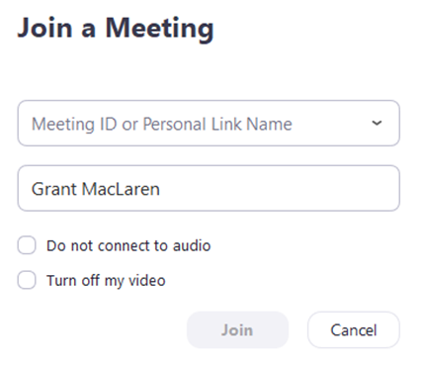

Figure 2.1: Join a Meeting as a Guest

|  |  |
| --- | --- |
|  |  |

Figure 2.2: Speaker and Microphone Testing

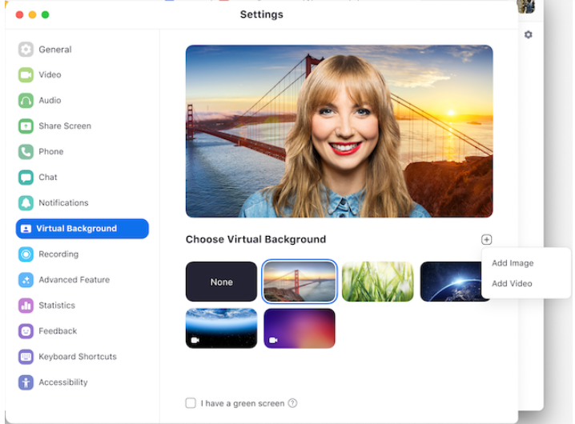

Figure 2.3: Upload Image or Video as Virtual Background

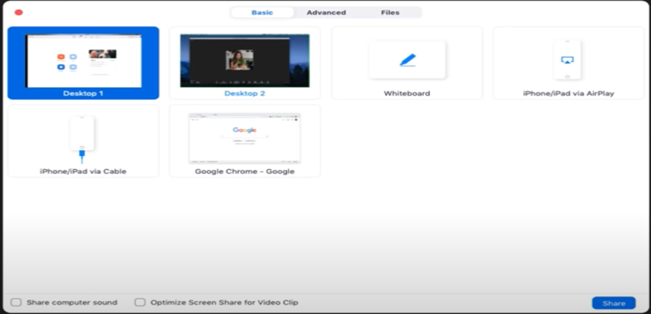

Figure 2.4: Different Screen Sharing Option of Zoom



Figure 2.5: Zoom’s Annotation Tools

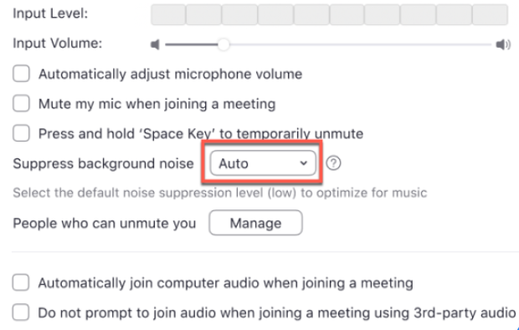

Figure 2.6: Background Noise Suppression

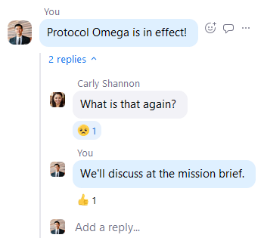

Figure 2.7: React to a Message

1. Cisco Webex

Adopted from <<https://www.webex.com/>>

Cisco Webex Meetings is a flexible audio and video conferencing system. It allows users to set up an effective virtual meeting with multiple productivity tools.

The user can download the Cisco Webex app on a computer or a mobile phone or open by a web browser. The user can register a Cisco Webex account by using an email address. To host a meeting, a user must first log in the Cisco Webex account as shown in Figure 2.8. The host can invite people to the personal room by sending the URL using email or instant message. If the user receives an email invitation that provides the information to join the meeting, then the user can join the meeting even he does not have a WebEx account as shown in Figure 2.9.

Before joining a meeting, the user can choose the audio and video settings. The user can choose the device to connect to audio, turn on or turn off the audio or video. Cisco Webex Meeting limits the background distractions that can disrupt a meeting. If the application detects background noise from the user’s microphone, it will show a message to ask the user to mute himself as shown in Figure 2.10.

Cisco Webex provides recording meeting feature to help those who absent to refer what was discussed in a meeting. Figure 2.11 shows two alternatives to record meetings in Cisco Webex, depending on Webex site configuration and the user’s account type. The first method is record meeting in the cloud, and the user will receive an email with the recording link after the meeting. The second method is starting a recording and save it to the personal computer after the meeting.

Cisco Webex Meetings also provides a feature to help the attendees to view what the host talking about by sharing the screen content. Figure 2.12 shows the options for sharing content: share the desktop, an application, a file or a whiteboard. During the meeting, a user can annotate a shared screen to highlight, explain, or point out information. The user can perform various activities while sharing a screen or whiteboard, like drawing, insert a text, place an arrow or draw a border to draw the attention of the attendees. The user may also save the annotation to the computer or mobile. Figure 2.13 shows the annotation tools in Webex.

Besides, the user can also use a poll to create and share questionnaires, which is useful for gathering feedback and voting. The user can create poll questions and answers and set the time to close the poll automatically. Only the presenter can view and share the results of the poll. Figure 2.14 shows the mange panels of a poll.

Cisco Webex Meetings provides schedule meeting feature with options tailored to the meeting. After the user schedule the meeting, the system will automatically send an invitation email to the invited people. If there are any changes to the scheduled meeting, for example, the meeting is postponed, the system will inform those who are invited.

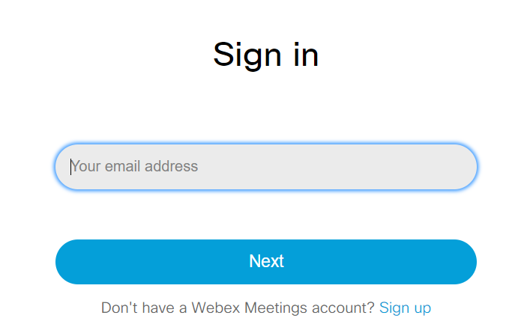

Figure 2.8: Login to Cisco Webex

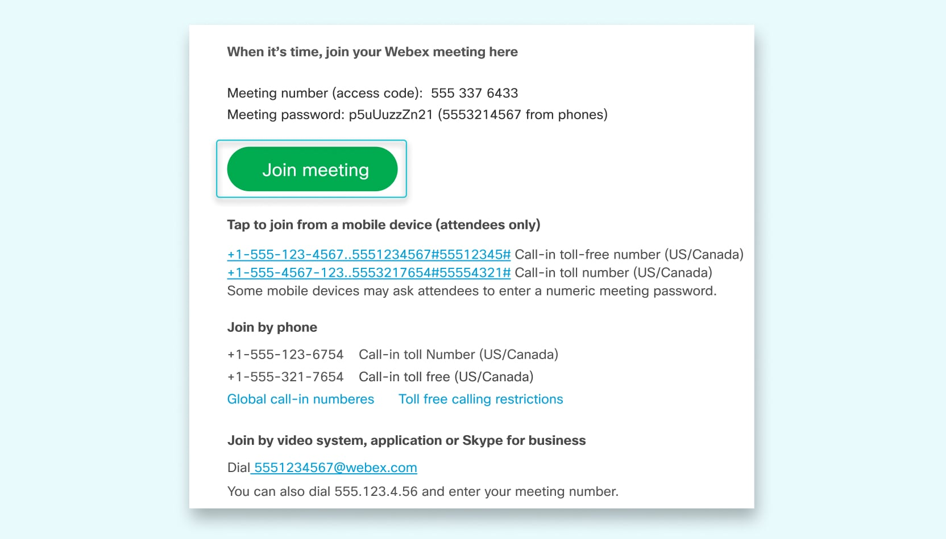

Figure 2.9: Join a Webex Meeting

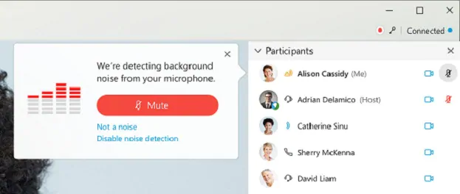

Figure 2.10: Webex Background Noise Detection



Figure 2.11: Recording Alternatives in Webex

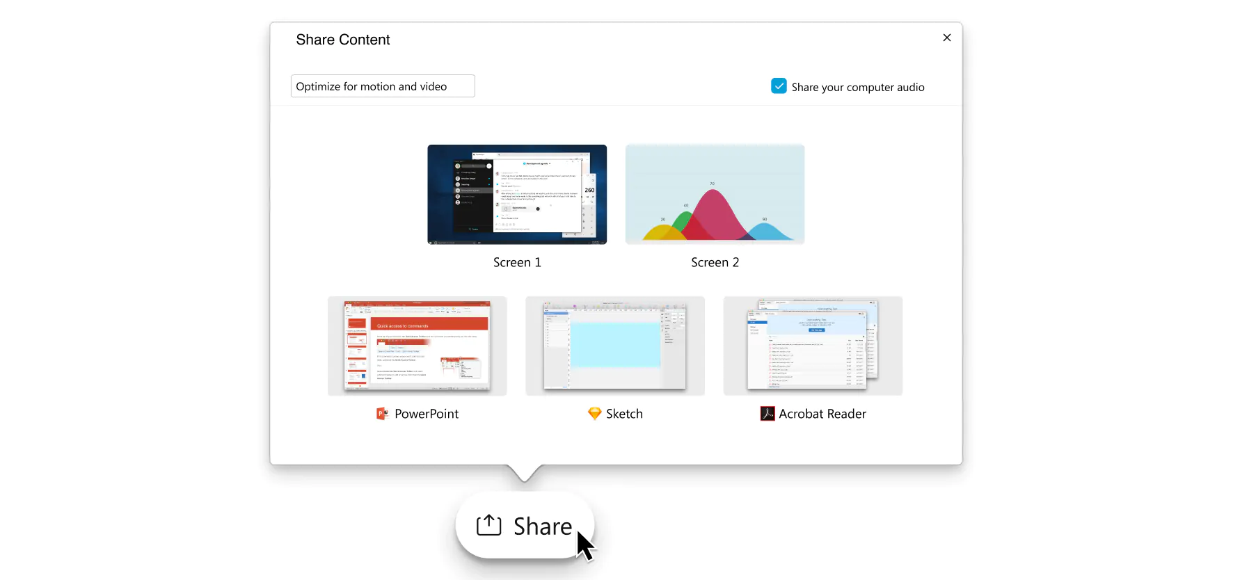

Figure 2.12: Share Content Options

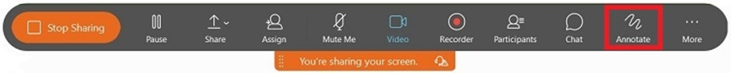

Figure 2.13: Annotation Tools

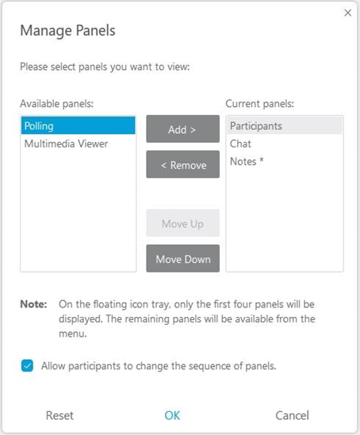

Figure 2.14: Poll Manage Panel

1. Microsoft Team

Adopted from <<https://www.microsoft.com/en-my/microsoft-365/microsoft-teams/group-chat-software>>

Microsoft Teams is a collaborative tool designed to enhance internal communication in a company. Microsoft Teams is famous among those companies that use Office 365 products.

A team can have one or many owners, members and guests. Each member of the Teams has a different role, and each role has different levels of access privileges. For instance, an owner can manage a team setting such as add and remove team members, add guests, change team setup, and manage administrative tasks. The people in a team are members. They can do activities such as send a message, view and upload documents. Guests are external stakeholders like partners or consultants who are invited by the host to join the team. They have limit capabilities to access some features.

The user can join a Teams meeting anytime, from any device, with a Team account. However, if the user does not have an account but receive an invitation to join a team, then the user can join the meeting using a Microsoft account. The user can choose to use the web browser if he does not want to download the app.

Before starting a meeting, the user must set a title, audio and video source. The host can invite people by typing the name or phone number or sharing the meeting link. There are a few ways that a user can join a meeting: join by link, join in a channel, join from a calendar and join from chat. The user can start recording a Teams meeting or call to capture the audio, video, and screen sharing activity. Teams shows a notification to all participants when a meeting recording starts. The recording will be stored to Microsoft Stream and available to all participants. The recording will stop automatically once all the participants leave the meeting.

The user can change the video background before or during a meeting by either blur the background or replace it entirely with any images from the computer. The user can preview the chosen background before applying it. Figure 2.15 shows how a user can blur the background during a meeting.

In Microsoft Team, the user can share the screen during a meeting or when catting with another user. Figure 2.16 shows the four options for screen sharing. Desktop allows the user to show everything on the screen, Window shows a specific app, PowerPoint shows a presentation while Browse allows user to find the file you to show. A red border will surround the sharing content when the user selects sharing.

The meeting participants can collaborate on a whiteboard and save the product after a meeting. Figure 2.17 shows several pens and tools for the user to annotate on a whiteboard. For example, marker, highlighter, eraser, ruler to draw straight lines, Text, Notes. The user may also insert an image or file from the library, Bing or take a picture using the device camera.

Microsoft Teams allows the user to organize the contacts into a group so that the user can search a contact easily. For example, the user can create a contact group and add people into it, rename or delete the group. Microsoft Teams will automatically set the status of a user. However, the user can also update their status such as available, busy, do not disturb, be right back and appear away as shown in Figure 2.18. Microsoft Teams also includes a chat service that allows users to communicate quickly without setting up a conference. Chats can be one-on-one or in a group.

In Teams, the calendar of a user is connected to the Exchange calendar. It enables the user to schedule a meeting in Outlook and Teams.

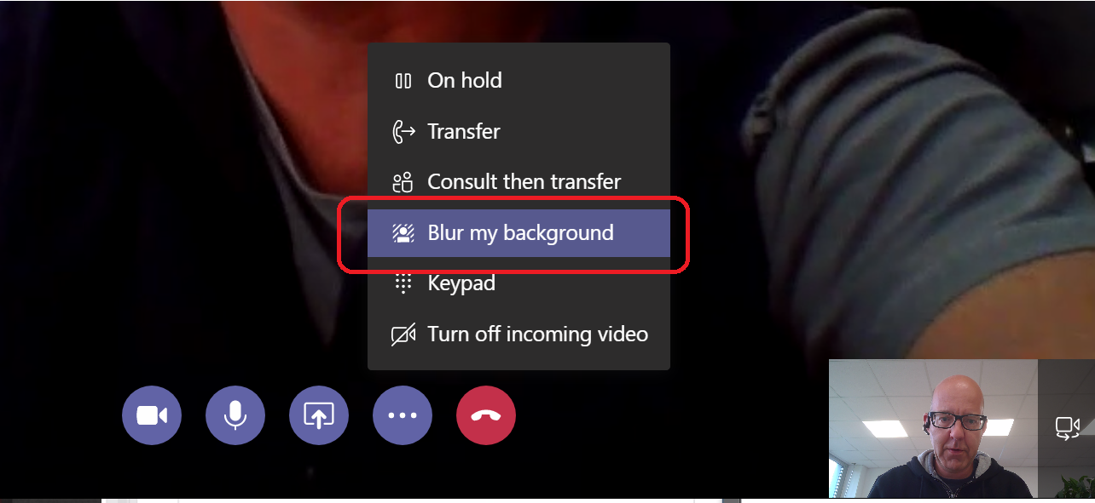

Figure 2.15: Blur the Meeting Background

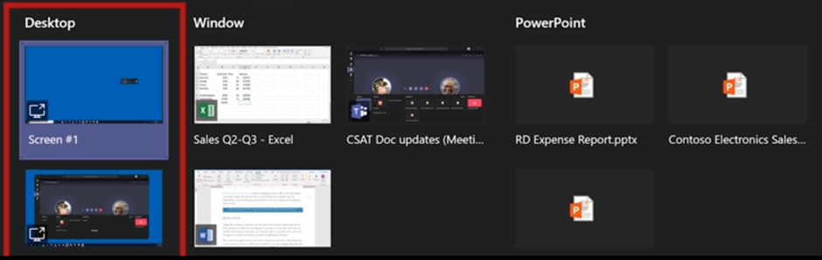

Figure 2.16: Screen Sharing Option

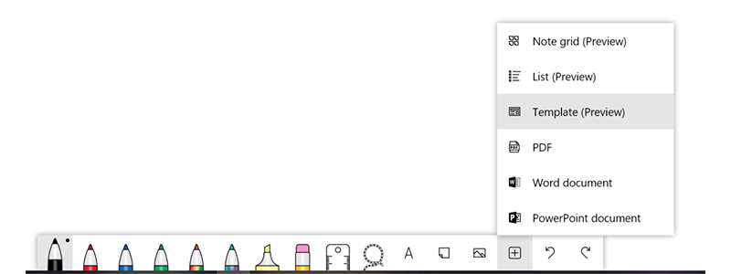

Figure 2.17: Whiteboard Tools

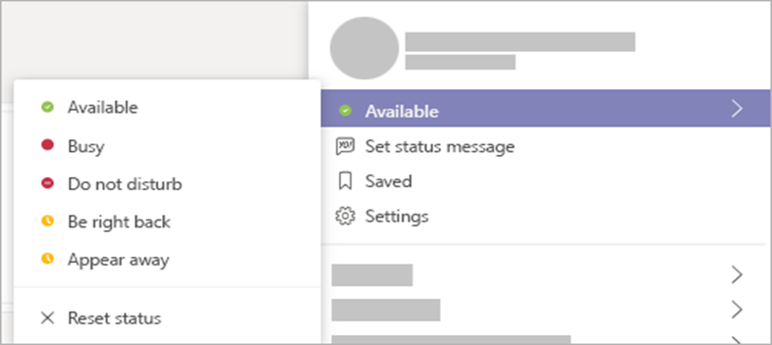

Figure 2.18: User Status Settings

### Development Methodology

#### Software Process

A software development life cycle (SDLC) (also known as software methodology) is a set framework that is applied to control, plan and develop software. There are many software development models used in various organizations and it is very useful for the organization. All these models have their own strength and limitations and there is no ideal model. It is important to choose the model based on the characteristics of the systems that are being developed. The Table shows four fundamental activities of software process and the explanation (Elgabry, 2017; Ulbert, 2014).

#### Waterfall Model

Waterfall model is the basic SDLC model. This model was used to be famous but today it is seldom used. However, it is important because all the other SDLC models are based on the classical waterfall model (GeeksforGeeks,2019). The phases of the waterfall model are: Requirements, Design, Implementation, Testing, and Maintenance (Elgabry, 2017; GeeksForGeeks, 2019; Ulbert, 2014)

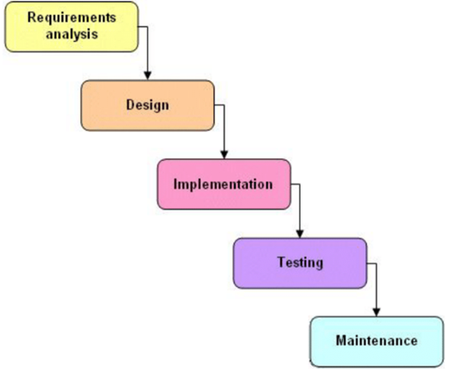

Figure 2.19: Waterfall Model (Rather and Bhatnagar, 2015)

Table 2.3: Advantages and Disadvantages of Waterfall Model (Elgabry,2017; Rather and Bhatnagar,2015; Sharma and Singh, 2015)

|  |
| --- |
| Advantages of Waterfall Model |
| 1. Simple and easy to comprehend. 2. Phases are processed one by one. 3. There is a clear definition of each stage in the model. 4. This model has a realistic and achievable milestones. 5. This model suitable for small projects and projects where there is a clear understanding of the requirements. |
| Disadvantages of Waterfall Model |
| 1. This model does not provide an error correction mechanism. 2. After the requirements specification process is done, it is impossible to adapt any scope changes. 3. This model suggests starting a new phase only after the preceding phase finish. However, phases could overlap in real projects. |

By theory, each phase should produce one or more documents to be authorized, and the subsequent phase should not begin while waiting for the preceding phase to finish. However, in reality, these phases overlap and pass data to each other. The model has a linear architecture that makes it extremely difficult to accept change during development. The model can only be implemented while specifications are fully established and are unlikely to alter. (Elgabry, 2017; Ulbert, 2014).

#### Prototyping Model

The prototyping model is a system development model in which a prototype is repeatedly developed, tested and then refined until it meets the user’s expected requirement then an actual system is developed (Sharma and Singh, 2015). A prototype allows the users to generate ideas for requirements and identify the strength and shortcoming in the software. Furthermore, it may expose the errors in the requirements and acts as a guide for the design phase and testing phase. (Elgabry,2017; Tanvir et al, 2017).

Table 2.4: Advantages and Disadvantages of Prototype Model (GeeksforGeeks, 2018; Rather and Bhatnagar,2015; Sharma and Singh,2015)

|  |
| --- |
| Advantages of Prototype Model |
| 1. Users are involved in the development 2. Provide a better understanding of the system being developed with the construct of user interface 3. Identify critical features and detect errors easily 4. Quicker user feedback able to refine the requirements in the early phase and leading to better solutions. 5. Missing functionality can be detected easily |
| Disadvantages of Prototype Model |
| 1. System’s complexity increases as the scope of the system may grow beyond initial plans. 2. The incomplete or inadequate reusable component may lead to project failure 3. The cost is high and not suitable for small scale projects |

The prototyping model is categorized into two types: throwaway and evolutionary. The purpose of using throwaway prototyping is to gain understanding about a design idea. Each prototype focus on one feature and it will be abandoned when the prototype is done testing (Elgabry,2017; Kahlid,2018; Sharma and Singh,2015). Throwaway prototyping is usually used in the early phases of design when the system requirements are still being considered (Elgabry, 2017; Kahlid,2018).

In evolutionary prototyping, the first prototype will present to the client or user to collect feedback then the prototypes are reused in a new test cycle. At some point the user agreed that the prototype fulfils all the requirements then finally the prototype will become the final product (Elgabry, 2017; Kahlid,2018) In contrast to throwaway prototyping, evolutionary prototyping is used in rather late development stages. It enables the involvement of end-user throughout the development process (GeeksforGeeks,2018; Sadabadi,2013).

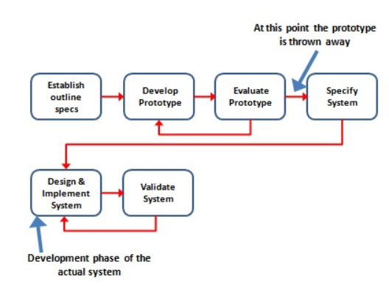

Figure 2.20: Throwaway Prototyping (Khalid,2018)

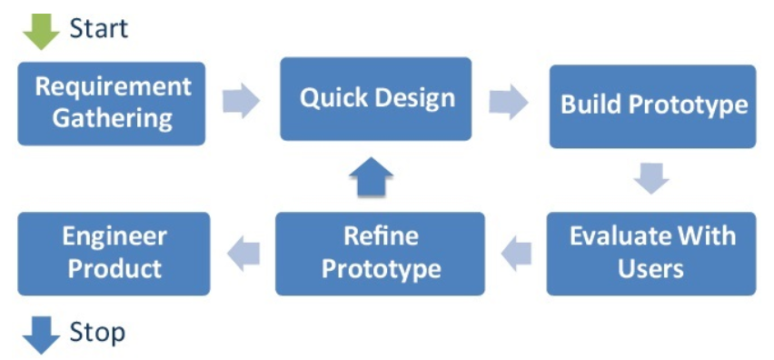

Figure 2.21: Evolutionary Prototyping (Khalid,2018)

The word fidelity explains how the prototypes can be differentiated from the end product, and how they can be modified to highlight design features (Walker et al, 2002). Low-fidelity prototypes show the overall design and the interface feel of a system. These prototypes are designed to interact, teach, and provide information, but not to test, evaluate, or act as a foundation for the source code. Low-fidelity prototypes are easily accessible as they can be displayed on cardboard, sketches, or whiteboards (Rudd, Stern and Isensee, 1996). Low-fidelity prototypes are typically limited function, are easily designed and have minimal or no features (Inbragimova, 2016). On the contrary, high-fidelity prototypes are completely interactive. Users can enter information in the text field, click buttons and interact with the user interface. (Rudd, Stern and Isensee, 1996). Axure, Form, Principle, Framer, Adobe XD, InVision, Proto.io are examples of web app prototyping tools (Inbragimova, 2016; Ye,2017).

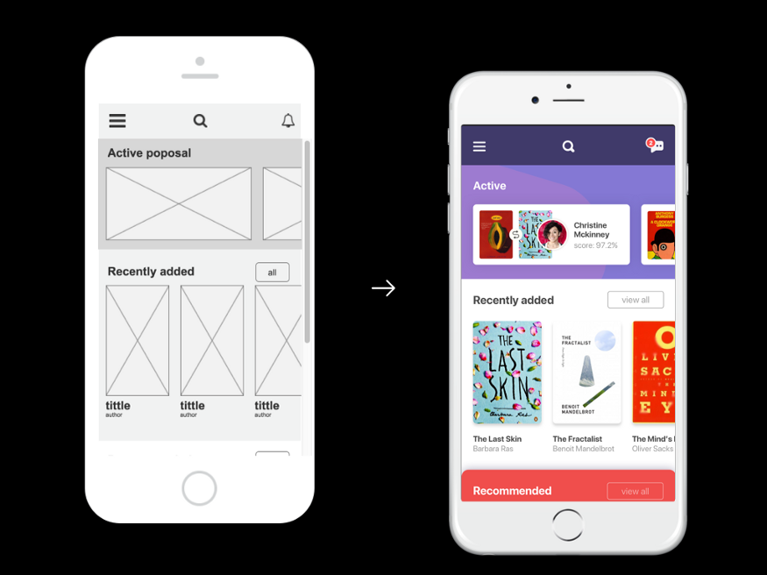

Figure 2.22: Low Fidelity vs High Fidelity Prototype (Pierzchała, 2018)

#### Spiral Model

Spiral model is a risk-driven software model driven that design to provide risk handling support (GeeksforGeeks,2018; Sharma and Singh, 2015). It looks like a spiral in its graphical model, with several loops. The precise number of spiral loops is depending on the project risks. A spiral loop is considered a phase and there are 4 phases: planning, risk analysis, engineering and evaluation (Elgabry, 2017; Govardhan and Munassar 2010).

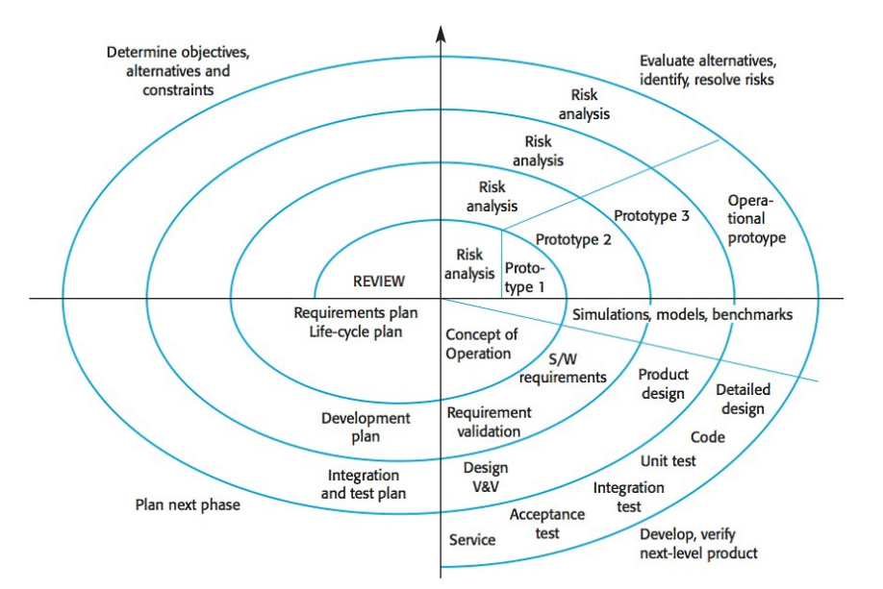

Figure 2.23: Spiral Model (Sharma and Singh, 2015)

Table 2.5: Advantages and Disadvantages of Spiral Model (Alshamrani and Bahattab,2015; Elgabry,2017; GeeksforGeeks, 2018; Rather and Bhatnagar,2015)

|  |
| --- |
| Advantages of Spiral Model |
| 1. Risk analysis and risk handling at every phase that enhances the risk avoidance 2. Good for large and complex projects 3. Flexible to adapt the change of requirements at a later phase |
| Disadvantages of Spiral Model |
| 1. This model is much more complex than other SDLC models due to many documentations required in the intermediate stages 2. The cost is high and not suitable for small and low-risk projects 3. High dependent on the risk analysis phase and require highly experienced experts to develop a successful project 4. Difficult to estimate the time due to the unknown number of phases at the beginning stage. |

### Communication Technology

#### Real-Time Communication

Real-time communication (RTC) is any mode of communication in which sender and recipient can exchange data over a channel without any delay. In this context, it is also known as live communication and it belongs to peer-to-peer communication (Rouse, 2020; Singh and Passi, 2014). RTC can take place in two transmission mode: half duplex and full duplex. In half duplex, the data transmission is bidirectional but asynchronously. For example, walkie-talkie. In full duplex, data transmission is bidirectional and concurrently. For instance, an internet telephone. (Singh and Passi, 2014).

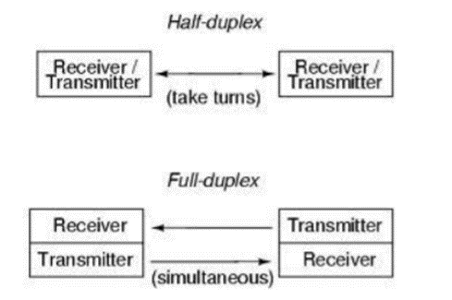

Figure 2.24: Modes of Transmission (Singh and Passi, 2014)

#### Application of Real-Time Communication

1. Instant Messaging

Instant Messaging is taking place in a private room, between two or more persons. It provides feature such as send a private chat and showing the online or offline status of a person in the contact list. Recently Instant Messaging became popular. This is due to the message instantly pop out on a user screen if the user switches to online mode, without waiting for the recipient to reply.

1. Live Video Conferencing

Live video conference is a conference that use communications technology to transmit audio and video data between two or more individuals at various locations. Each person must have a camera, speaker and microphone connected. Example, Skype enables the user to share a screen or a file during the video conference.

1. Internet Telephony and VoIP

Internet telephony allows the user to start a telephone conversation using the Internet. Tools to set up computer-to-computer telephony requires a cable modem, a microphone and a voice-over with the support of telephony apps built on both sides. VoIP is an internet-based communication approach where software and hardware operate together to transmit phone calls (Singh and Passi, 2014). There is many software for Internet telephony, for instance, pool talk, net meeting, and Viber.

1. Multimedia Multicast

Multimedia information is a form of audio and radio. The multimedia server is often used to collect data from diverse receivers located at geographical locations, for example, Facebook and Twitter.

#### Web Sockets

Web Sockets offers full duplex communication channels through a single TCP connection and keep it running as long as necessary. It enables bidirectional communication between browsers and servers. Both parties can instantly share data simultaneously and close the connection easily (Chowhury,2018; Educba, n.d.; Tsahi, 2019). Web Sockets supports real concurrency and performance optimisation to create more responsive and rich web applications. It is also very efficient if the application needs frequent messages such as a notification system. It also provides a data framing feature that includes masking every message sent so that the data is encrypted. (Chowhury,2018).

#### WebRTC

WebRTC is a peer-to-peer type of transport that provides real-time communication between browsers (clients). It can use UDP, TCP, SCTP, or more abstract layers since it is transport-agnostic (Chowhury, 2018). The WebRTC API includes media capture, encoding and decoding, transport layer, audio and video, and session management (Educba, n.d.). It is designed for high-performance, high-quality communication and high-volume data transmission.

WebRTC provides useful key JavaScript API elements for the developer to acquire and communicate streaming data (Dutton,2012; Tsahi,2019)

1. getUserMedia or Media Stream enables the access to data streams from the user’s device such as camera and microphone.
2. MediaRecorder records audio and video available from the user’s device.
3. RTCPeerConnection allows peer-to-peer audio and video calling with facilities for data encryption and bandwidth management. It includes initialise, monitor, and close the connection.
4. RTCDataChannel enables peer-to-peer bidirectional data transmission.

### Conclusion

In this chapter, various studies had been carried out to provide a basic understanding of video conferencing. There are four types of video conferencing systems: telepresence, integrated, desktop, service-based and codec. Video conferencing has been widely applied such as meeting or collaboration, education, video interviews, work from home and healthcare professionals. Both videos conferencing and face-to-face meetings have distinct pro and con. Travel constraint, meeting content and social relationship are factors to influence decisions to select the mode of communication. This chapter also compared three existing video conferencing: Zoom, Cisco Webex and Microsoft Team. Furthermore, different software development methodologies were compared. This chapter also studies about the application of real-time communication and two RTC protocols: Web Sockets and WebRTC.

## METHODOLOGY AND WORK PLAN

### Introduction

After reviewing the studies on different software development method in the previous chapter, evolutionary prototyping methodology has been chosen to apply in the development of web-based video conferencing application. This chapter includes a Work breakdown structure (WBS), Gantt chart and explanation on the development tool used.

### System Development Methodology

In order to create great software, one needs to accomplish a variety of complicated tasks, and if any of the tasks fail, the whole project will fail. Software development methodologies are then established to help keeping the development plan on track (Stephens,2015). In this project, evolutionary prototyping is chosen as the methodology. The main reason for using this approach is to give users a more realistic feel about how the completed system would look like. The prototype will evolve over time until it finally becomes the completed application and satisfies consumer requirements.

#### Requirement Gathering Phase

The most crucial part of a software project is requirement gathering. This is to make sure that the developed product will address the problems of the users and the specifications meet the expectation of the users. Gather requirements at the project's beginning to find out what functionality to create. The requirements will lead the development and make sure all goes in the right direction. The requirements at the project's completion validate that the completed product is really achieving what it is expected to do (Stephens,2015).

Numerous studies and researches were performed to determine the project background, the problem statement, the goal, the solution, the approach and the scope of the project. In addition, the various similar systems were analysed and compared to determine the possible beneficial functionalities of these systems so that these features may be integrated into the new system to create a more reliable system.

In this project, the requirements were categorized into functional and non-functional requirements. After that, use case diagram, ER Diagram and user interface designs were drawn. These diagrams give a high-level view of the application and illustrate the features that it will provide to the users.

#### Develop Prototype

There are three phases in an iterative process: build a prototype, evaluate by users and refine the prototype. The number of iterations generally depends on the needs of a project so the number may vary from project to project. For this project, there are two major iterations of prototype implementation.

1. First Prototype Iteration

The product scope for the first prototype iteration is build the entire system by writing code using the chosen tools and programming language. The objective of this iteration is to develop a workable prototype with basic features and integrated with back end service. The use case diagram and use case descriptions are used to provide a detailed process flow of the application. After the first prototype is developed, the working prototype will be tested by the volunteers. During a test, the volunteers need to complete some tasks while the observer will watch and record. After the test, the volunteers must complete a survey. The feedbacks and suggestions are recorded and incorporated into the second iteration.

1. Second Prototype Iteration

The product scope of the second iteration was a prototype with more comprehensive and complete features. In the second iteration, the objective is to improve the user experience. The second prototype will be tested by the same volunteers and the testing process is same as the first prototype. The iterative process is repeated until the final prototype meets the user requirements and expectations.

#### Product Deliver Phase

Once the final prototype is agreed and approved by the stakeholders, the prototype will be finalized. Then, various tests will be carried out to make sure that the system is working well, for example, unit testing, integration testing, system testing and user acceptance testing.

### Work Plan

Esther Cohen (2018) clarified that all the tasks a project needs to achieve can described by a work breakdown structure, categorized into several levels and presented graphically. This project used the WBS and Gantt chart to plan the project effectively. The top-down approach was used in which all the complex tasks are subdivided into small and simple tasks. A Gantt chart was used track projects from the beginning (June 2020) to the end (April 2020) of this project. Four key phases of this project include planning, design, development and testing.

#### Work Breakdown Structure (Detailed)

1. Planning

1.1 Perform background research

1.2 Determine problem statement

1.3 Define project objectives

1.4 Determine project’s proposed solution

1.5 Determine project’s proposed approach

1.6 Determine project’s scope

1.7 Perform literature review

1.7.1 Research on video conferencing

1.7.2 Research on development methodology

1.7.3 Research on communication technology

1.8 Methodology and Work Plan

1.8.1 Choose appropriate methodology

1.8.2 Develop work breakdown structure

1.8.3 Develop Gantt chart

1.8.4 Choose development tools

2. Design

2.1 Develop use case diagrams

2.1.1 Develop use case descriptions

2.2 Develop data models

2.2.1 Develop conceptual data model

2.2.2 Develop logical data model

2.2.3 Develop physical data model

2.3 Develop Data Flow Diagram

2.3.1 Develop Context Diagram

2.3.2 Develop Level 0 DFD

2.3.3 Develop Level 1 DFD

2.4 Develop User Interface Prototypes

2.4.1 Develop Low-fidelity Prototype

2.4.2 Develop High-fidelity Prototype

3 Development

3.1 Develop prototype

3.1.1 First prototype iteration

3.1.1.1 Implement features of system

3.1.1.2 Evaluate prototype

3.1.1.3Refine prototype

3.1.2 Second prototype iteration

3.1.2.1 Improve first prototype

3.1.2.2 Evaluate prototype

3.1.2.3 Refine prototype

3.2 Product engineering/ delivery

3.2.1 Enhance final prototype

4 Testing

4.1 Perform unit testing

4.2 Perform integration testing

4.3 Perform system testing

4.4 Perform user acceptance testing

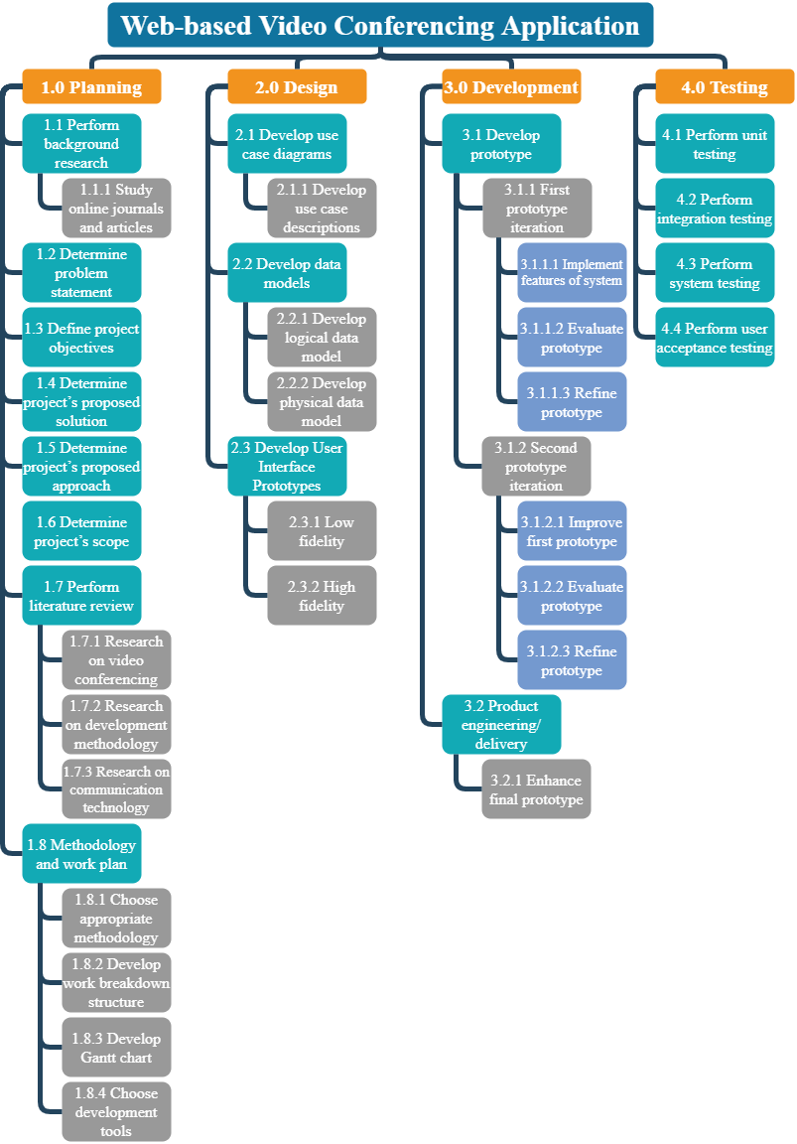

Figure 3.1: Work Breakdown Structure

#### Gantt Chart

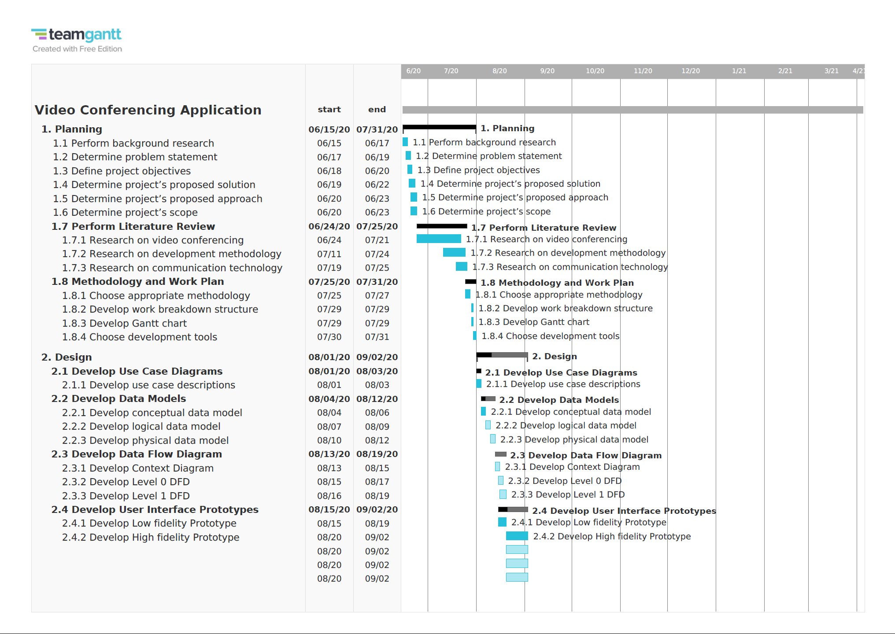

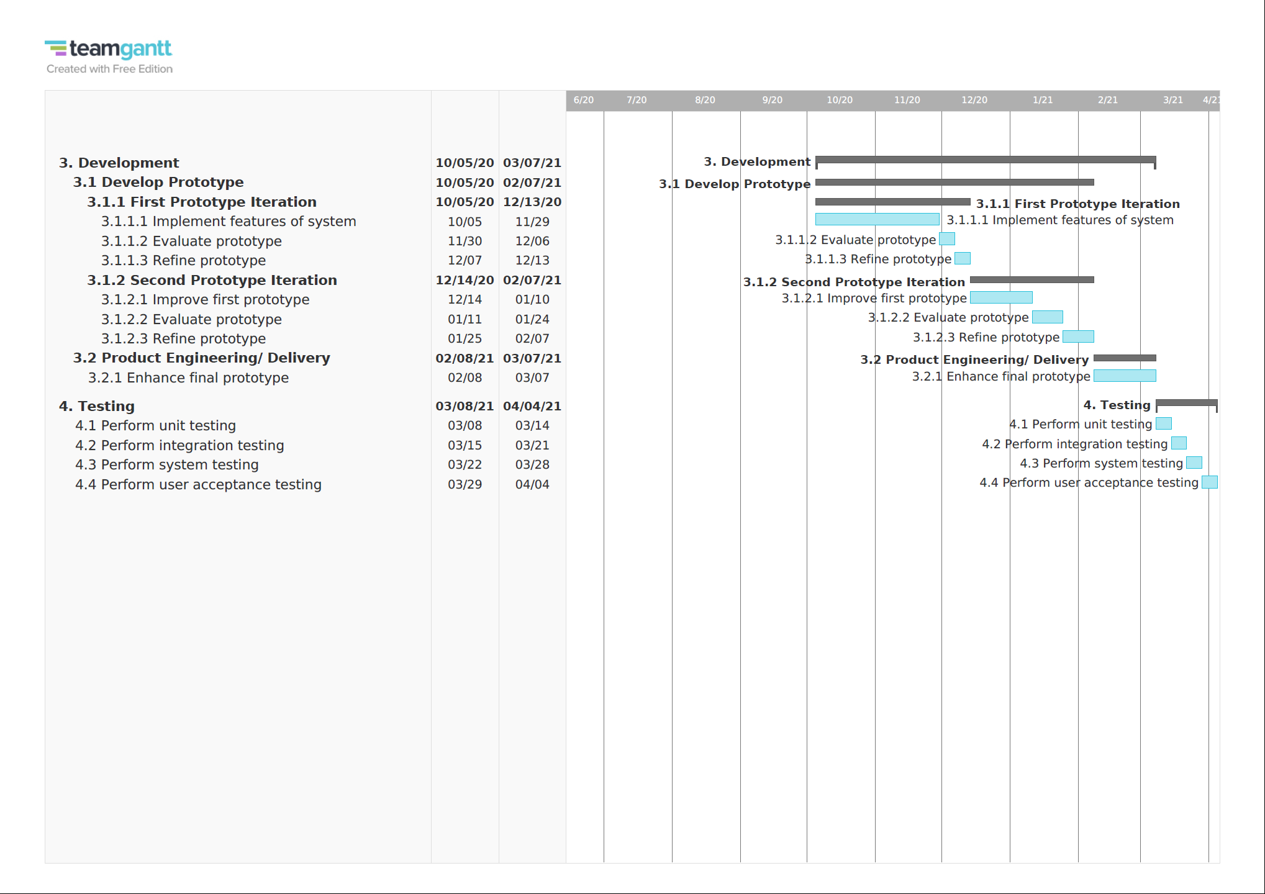

### Development Tools

#### Bootstrap

Bootstrap was released in August 2011 by Mark Otto and Jacob Thornton (Spurlock, 2013). It is the most common open source platform for creating responsive websites using HTML, CSS and JavaScript. Segal (n.d.) states that Bootstrap supports JavaScript plugins and includes font style, forms, links, menus, modals, carousel and many more. The reason of choosing Bootstrap is to design of a responsive website faster, since it is simple to set up and completely customizable.

#### Visual Studio Code

Visual Studio Code is a simple yet powerful Windows, macOS and Linux code editor. It provides built-in support for JavaScript, TypeScript, and Node.js, with various additional language extensions. The reason of choosing Visual Studio Code as a code editor is because it is easy to install and free to use.

#### GitHub

Github is used as a version control system to tracks the various versions of the code. Every file on GitHub has a history to record the modifications that have occurred at different times. Github is selected to keep track of the work and easily navigate among different versions of the files while maintaining an online backup.

#### WampServer

WampServer (Windows, Apache, MySQL and PHP) is a virtual server that supports live website for web development and internal testing (Artūras, 2019). Since it is stored localized on the machine, a web developer can test websites in a web browser without uploading them to the Internet (Artūras, 2019; TechTerms, 2013). This project uses WampServer because it can save time and provides a secure and care-free environment.

#### Composer and Laravel

Laravel is one of the famous PHP frameworks on a Windows server. Composer is a tool used by Laravel to manage dependencies. Therefore, Composer must be installed before using Laravel. This project use Laravel because is has clean and simple routing.

#### Web Programming Language

Web programming language is very important to control the actions of a machine. This project uses different programming languages to write the source code.

First is HTML (Hyper Text Markup Language). HTML is the standard mark-up language for webpages, and it contains many elements like heading, title, link, tables and so on. HTML5 is the latest version of HTML which has new features to interact with internet technologies for content structure and layout. According to MDN contributors (2019), HTML5 supports web socket enabling full duplex communication between client and server. In addition, HTML5 supports both audio and video through the integration into it. Compared to HTML, HTML5 is more able to handle errors, but also has a JavaScript web worker API that allows JavaScript and browser interface to execute in different threads (Educba, n.d.).

Second is CSS (Cascading Style Sheets). CSS is used to style an HTML element like font size, font family, background colour. In this project, CSS is used to design the appearance of the web application. Third is JavaScript. It supports functional and object-oriented programming style. In this project, JavaScript is used to program the behaviour of the webpages, like show and hide an HTML element. Fourth is PHP (Hypertext Pre-processor). PHP is a widely used open source server-side scripting language. It provides many features like send and receive data, control user access, data encryption and so on. In this project, PHP is used to perform CRUD operation on the files on the server. Fifth is SQL (Structures Query Language). It is a standard language to store, manage and retrieve data in databases. In this project, SQL is used to access and manipulate databases.

#### Chrome DevTools

Chrome provides a set of built-in tools for web developers. It provides features such as inspect network activity, run and debug JavaScript in the console. In this project, Chrome DevTools provides a device mode's screen emulator to test the responsiveness of the web application.

### Conclusion

This chapter contains a detailed description of how the evolutionary prototyping methodology was applied to this project, a work breakdown structure, a Gantt chart as well as a list of useful development tools used to build the web-based video conferencing application.

## PROJECT INITIAL SPECIFICATION

### Introduction

This chapter contains a list of all functional requirements, a use case diagram and use case descriptions. A use case diagram can demonstrate the user’s interaction with the system whereas a use case description is used to explain each use case in detail.

### Functional Requirements

#### Video Conference Application

1. Register and Signing in

Host and Participant

1. The system must allow the host and participant to register for a new account.
2. The system must allow the host and participant to log in to the application.
3. The system must provide a dashboard for the host and participant to access the features after log in.
4. The system must allow the host and participant to log out the application.
5. Contact List

Host and Participant

1. The system must allow the host and participant to view a list of contact of other users.
2. The system must allow the host and participant to view the status of a user.
3. The system must allow the host and participant to add a new user to the contact list.
4. The system must allow the host and participant to edit the contact list.
5. The system must allow the host and participant to delete the user from the contact list.
6. The system must allow the host and participant to search a user from the contact list.
7. Schedule a Meeting

Host and Participant

1. The system must allow the host and participant to view the upcoming meeting.

Host

1. The system must allow the host to schedule a meeting.
2. The system must allow the host to edit a scheduled meeting detail.
3. The system must allow the host to delete a scheduled meeting.
4. Agenda Planner

Host, Participant and Guest

1. The system must allow the host, participant and guest to view the meeting agenda of a meeting.

Host

1. The system must allow the host to create a new meeting agenda.
2. The system must allow the host to edit a meeting agenda.
3. The system must allow the host to delete a meeting agenda.
4. Meeting

Host, Participant and Guest

1. The system must allow the host, participant and guest to view all the attendees joining a meeting.
2. The system must allow the host, participant and guest to turn on or off the audio.
3. The system must allow the host, participant and guest to turn on or off the camera.

Host

1. The system must allow the host to create a meeting room.
2. The system must allow the host to create a meeting channel.
3. The system must allow the host to start and end a meeting.
4. The system must allow the host to invite participants or guests to the meeting room.
5. The system must allow the host to share screen in a meeting.
6. The system must allow the host to record a meeting.

Participant

1. The system must allow the participant to join a meeting room using a meeting room ID.
2. The system must allow the participant to gain points for attending a meeting.

Guest

1. The system must allow the guest to join a meeting room using a meeting room ID.
2. The system must allow the guest to send feedback after the meeting.
3. The system must allow the guest to quit the application after the meeting.
4. Test Messaging

Host and Participant

1. The system must allow the host and participant to view chat conversations with another user.
2. The system must allow the host and participant to send chat to other user in the contact list.
3. Speed Test

Host and Participant

1. The system must allow the host and participant to test the internet speed.
2. Profile Management and Setting

Host and Participant

1. The system must allow the host and participant to view the profile.
2. The system must allow the host and participant to edit the profile.
3. The system must allow the host and participant to delete the profile.
4. The system must allow the host and participant to turn on or off the notification.
5. The system must allow the host and participant to change the status (Online / Offline / Busy).
6. Notification

Host and Participant

1. The system must send a notification to the participant if the participant is added to the meeting room.
2. Feedback

Host, Participant and Guest

1. The system must allow the host, participant and guest to send feedback.
2. Point System

Host and Participant

1. The system must allow the host and participant to view the point gain by another user.

#### Administrator System

1. The system must allow the admin to log in / log out to the admin application.
2. The system must provide a dashboard for the admin to access the features after log in.
3. The system must allow the admin to view the list of users.
4. The system must allow the admin to view the feedback of the user.
5. The system must allow the admin to create a new admin account.
6. The system must allow the admin to edit the admin profile.
7. The system must allow the admin to delete the admin account.

### Non-functional Requirements

1. Usability Requirement
2. The system shall provide a user manual to allow the users to be familiar to all the system’s features.
3. The system shall have responsive user interface designs.
4. Performance Requirement
5. The system shall allow up to 5 users to join a meeting concurrently.
6. Operational Requirement
7. The system shall only be accessed over the Internet.
8. Development Requirement
9. The system shall be built with web programming languages (PHP, CSS, HTML, SQL).
10. Accuracy Requirement
11. The mobile app shall enable spell checked for all comment fields.
12. Physical Requirement

Table 4.1: Physical Requirement

|  |  |
| --- | --- |
| **System Requirements** | **Descriptions** |
| Web Browser | Google Chrome, Mozilla Firefox, Safari, Opera |
| Camera | A webcam capable of producing high-quality video |
| Bandwidth | 600kbps (up/down) for high quality video  1.2 Mbps (up/down) for 720p HD video |
| Ram and Processor | A computer with at least 1 GB of RAM and a dual-core processor. |
| Audio | Built-in microphone or Headset |

### Use Case

#### Use Case Diagram

A use case is a description of interactions between actors and system. A use case diagram is used to describe the video conferencing application. It consists of four actors: administrator, host, participant and guest, a series of use cases and their relationship.

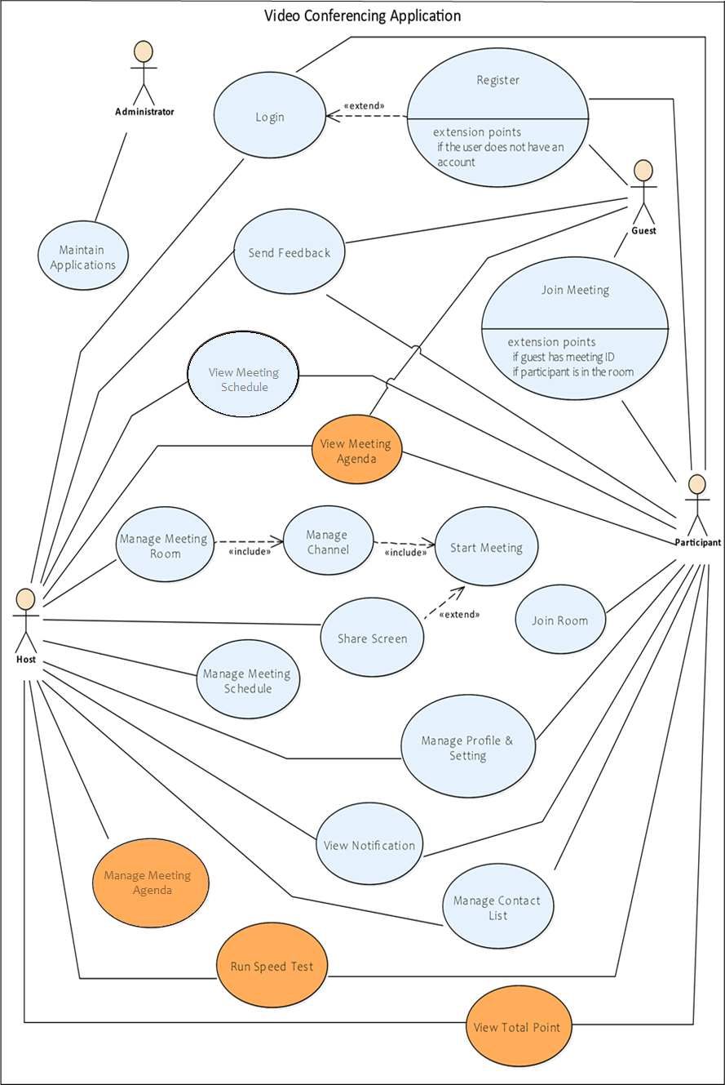

Figure 4.1: Use Case Diagram

#### Use Case Description

|  |  |
| --- | --- |
| Use Case ID | 1 |
| Use Case Name | Login |
| Actors | Host, Participant |
| Description | User logs in to the video conferencing application. |
| Pre-condition | User must have a registered account. |
| Post-condition | - |
| Normal Flow | 1. A user enters email and password.  2. The system validates user email and password.  3. The system redirects to the user’s dashboard. |
| Alternative Flow | 2.1 The email or password is wrong.  2.1.1 The system displays an error message. |

|  |  |
| --- | --- |
| Use Case ID | 2 |
| Use Case Name | Register |
| Actors | Host, Participant, Guest |
| Description | User registers for a new account. |
| Pre-condition | - |
| Post-condition | - |
| Normal Flow | 1. The user enters username, email, password and confirm-password.  2. The system validates username, email, password and confirm-password.  3. The system displays a message to indicate |
| Alternative Flow | 2.1 Duplicated accounts detected.  2.1.1 The system displays an error message. |

|  |  |
| --- | --- |
| Use Case ID | 3 |
| Use Case Name | Manage Contact List |
| Actors | Host, Participant |
| Description | The user adds, edits and deletes a contact. |
| Pre-condition | - |
| Post-condition | - |
| Normal Flow | A. Add contact  1. The user selects contact feature.  2. The user selects add contact button.  3. The user enters username or user email.  4. The user selects add user button. |
| Alternative Flow | 3.1 The system validates the user inputs  3.1.1 If the inputs match one or more user, the system shows the user  3.1.2 If the inputs do not match a user, the system shows a message |

|  |  |
| --- | --- |
| Use Case ID | 4 |
| Use Case Name | Manage Profile and Setting |
| Actors | Host, Participant |
| Description | The user manages the profile and customizes the settings. |
| Pre-condition | The user has registered an account and sign-in to the application. |
| Post-condition | - |
| Normal Flow | A. Edit Profile Picture  1. The user selects setting feature.  2. The user selects my account tab.  3. The system shows the user’s current profile picture.  4. The user selects upload new profile picture.  5. The user clicks apply button to save the change.  B. Edit Personal Info  1. The user selects setting feature.  2. The user selects my account tab.  3. The system shows user personal info.  4. The user edits the personal info.  5. The user clicks apply button to save change.  C. Edit Password  1. The user selects setting feature.  2. The user selects my account tab.  3. The system shows user personal info.  4. The user select edits the password.  5. The user select apply button to save change.  D. Delete Account  1. The user selects setting feature.  2. The user selects my account tab.  3. The system shows user personal info.  4. The user selects delete account.  E. Edit Notification  1. The user selects setting feature.  2. The user selects notification tab.  3. The user turns on/off the notification.  F. Edit Status  1. The user selects setting feature.  2. The user selects status tab.  3. The user selects the status shown to another user.  4. The user selects the apply button to save the change. |
| Alternative Flow | C. Edit Password  4.1 The system shows a message for the user to enter the current password.  4.1.1 If current password matches, user can enter new password.  4.1.2 If the current password does not match, the system will show an error message.  D. Delete Account  4.1 The system will send a message for the user to enter the current password.  4.1.1 If current password matches, the user can delete the account.  4.1.2 If the old password does not match, the system will show an error message. |

|  |  |
| --- | --- |
| Use Case ID | 5 |
| Use Case Name | Manage Meeting Schedule |
| Actors | Host |
| Description | The host creates, edits and deletes a meeting schedule. |
| Pre-condition | - |
| Post-condition | - |
| Normal Flow | A. Create Meeting Schedule  1. The host clicks to create a meeting into the meeting schedule.  2. The host enters details of a meeting.  3. The host clicks the add button.  3. The system shows the meeting schedule.  B. Edit Meeting Schedule  1. The host selects view schedule feature.  2. The host selects to edit a meeting schedule.  3. The host changes the details of the meeting schedule.  4. The host submits the change.  5. The system shows the meeting schedule.  C. Delete Meeting Schedule  1. The host selects view schedule feature.  2. The host selects to delete a meeting schedule.  3. The system shows the meeting schedule. |
| Alternative Flow | A. Create Meeting Schedule  3.1. The system validates the input of host entered.  3.1.1 If the inputs are valid, create a meeting into the schedule successfully.  2.1.2 If the inputs are invalid, the system shows an error message.  B. Edit Meeting Schedule  4.1. The system validates the input of host entered.  4.1.1 If the inputs are valid, save the change.  4.1.2 If the inputs are invalid, shows an error message.  C. Delete Meeting Schedule  2.1. The system shows a message to confirm delete action.  2.1.1 If the host confirms the delete action, the meeting will be deleted. |

|  |  |
| --- | --- |
| Use Case ID | 6 |
| Use Case Name | View Meeting Schedule |
| Actors | Host, Participant |
| Description | The user views the meeting schedule. |
| Pre-condition | The host created the meeting schedule. |
| Post-condition | - |
| Normal Flow | 1. The user selects view meeting schedule feature.  2. The system shows the meeting schedule.  3. The user clicks to see the details of a scheduled meeting. |
| Alternative Flow | 1.1 If the meeting schedule is empty  1.1.1 The system will show that the meeting schedule is empty. |

|  |  |
| --- | --- |
| Use Case ID | 7 |
| Use Case Name | Manage Agenda |
| Actors | Host |
| Description | The host creates, edits and deletes a meeting agenda. |
| Pre-condition | The host creates a meeting schedule. |
| Post-condition | - |
| Normal Flow | A. Create Meeting Agenda  1. The host clicks to create a meeting agenda.  2. The host enters details of a meeting and the agenda.  3. The host clicks the add button.  3. The system shows the meeting agenda.  B. Edit Meeting Agenda  1. The host selects view agenda feature.  2. The host selects to edit a meeting agenda.  3. The host changes the details of the meeting agenda.  4. The host submits the change.  5. The system shows the meeting agenda.  C. Delete Meeting Agenda  1. The host selects view agenda feature.  2. The host selects to delete a meeting agenda.  3. The system shows the meeting agenda. |
| Alternative Flow | A. Create Meeting Agenda  3.1. The system validates the input of host entered.  3.1.1 If the inputs are valid, create a meeting agenda successfully.  2.1.2 If the inputs are invalid, the system shows an error message.  B. Edit Meeting Agenda  4.1. The system validates the input of host entered.  4.1.1 If the inputs are valid, save the change.  4.1.2 If the inputs are invalid, shows an error message.  C. Delete Meeting Agenda  2.1. The system shows a message to confirm delete action.  2.1.1 If the host confirms the delete action, the meeting agenda will be deleted. |

|  |  |
| --- | --- |
| Use Case ID | 8 |
| Use Case Name | View Meeting Agenda |
| Actors | Host, Participant, Guest |
| Description | The user views the meeting agenda. |
| Pre-condition | The host has created the meeting schedule. |
| Post-condition | - |
| Normal Flow | 1. The user selects to view the meeting agenda.  2. The system extracts the meeting agenda from the database and display to the user. |
| Alternative Flow | - |

|  |  |
| --- | --- |
| Use Case ID | 9 |
| Use Case Name | Join Meeting Room |
| Actors | Participant |
| Description | The participant joins a meeting room. |
| Pre-condition | 1. The host has created a meeting room.  2. The participant has the meeting room ID. |
| Post-condition | - |
| Normal Flow | 1. The participant selects the room feature.  2. The participant selects to join a room.  3. The participant enters meeting room ID.  4. The system shows meeting room details. |
| Alternative Flow | 3.1 The system validates the meeting room ID  3.1.1 If the meeting room ID is invalid, the system shows an error message. |

|  |  |
| --- | --- |
| Use Case ID | 10 |
| Use Case Name | Manage Meeting Room |
| Actors | Host |
| Description | The host creates, edits and deletes a meeting room. |
| Pre-condition | - |
| Post-condition | - |
| Normal Flow | A. Create Meeting Room  1. The host clicks to create a meeting room.  2. The host enters details of a meeting room.  3. The host clicks the add button.  3. The system shows the meeting room list.  B. Edit Meeting Room  1. The host selects view room feature.  2. The host selects to edit a meeting room.  3. The host changes the details of the meeting room.  4. The host submits the change.  5. The system shows the meeting room list.  C. Delete Meeting Room  1. The host selects view room feature.  2. The host selects to delete a meeting room.  3. The system shows the meeting room list. |
| Alternative Flow | A. Create Meeting Room  3.1. The system validates the input of host entered.  3.1.1 If the inputs are valid, create a meeting room successfully.  2.1.2 If the inputs are invalid, the system shows an error message.  B. Edit Meeting Room  4.1. The system validates the input of host entered.  4.1.1 If the inputs are valid, save the change.  4.1.2 If the inputs are invalid, shows an error message.  C. Delete Meeting Room  2.1. The system shows a message to confirm delete action.  2.1.1 If the host confirms the delete action, the meeting room will be deleted. |

|  |  |
| --- | --- |
| Use Case ID | 11 |
| Use Case Name | Manage Meeting Channel |
| Actors | Host |
| Description | The host creates, edits and deletes a meeting channel. |
| Pre-condition | The host had created a meeting room. |
| Post-condition | - |
| Normal Flow | A. Create Meeting Channel  1. The host clicks to create a meeting channel.  2. The host enters details of a meeting channel.  3. The host clicks the add button.  3. The system shows the meeting channel list.  B. Edit Meeting Channel  1. The host selects view channel feature.  2. The host selects to edit a meeting channel.  3. The host changes the details of the meeting channel.  4. The host submits the change.  5. The system shows the meeting channel list.  C. Delete Meeting Channel  1. The host selects the view channel feature.  2. The host selects to delete a meeting channel.  3. The system shows the meeting channel list. |
| Alternative Flow | A. Create Meeting Channel  3.1. The system validates the input of user entered.  3.1.1 If the inputs are valid, create a meeting channel successfully.  2.1.2 If the inputs are invalid, the system shows an error message.  B. Edit Meeting Channel  4.1. The system validates the input of user entered.  4.1.1 If the inputs are valid, save the change.  4.1.2 If the inputs are invalid, shows an error message.  C. Delete Meeting Channel  2.1. The system shows a message to confirm delete action.  2.1.1 If the user confirms the delete action, the meeting channel will be deleted. |

|  |  |
| --- | --- |
| Use Case ID | 12 |
| Use Case Name | Start Meeting |
| Actors | Host |
| Description | The host can start a meeting. |
| Pre-condition | The host has created a meeting room and a channel. |
| Post-condition | - |
| Normal Flow | 1. The host selects meeting room feature.  2. The system shows a list of rooms.  3. The host selects a meeting room from the list.  4. The system shows a list of channels.  5. The host selects a channel from the list.  6. The host selects button to starts a meeting.  7. The host invites participants/guest to join the meeting.  8. The host turns on/off the audio.  9. The host turns on/ off the video.  10. The host starts /stops recording the meeting. |
| Alternative Flow | - |

|  |  |
| --- | --- |
| Use Case ID | 13 |
| Use Case Name | Join Meeting |
| Actors | Participant, Guest |
| Description | User joins a meeting. |
| Pre-condition | 1. Participant is invited by the host to the meeting room.  2. Guest has a meeting ID. |
| Post-condition | - |
| Normal Flow | 1. The user joins a meeting.  2. The system adds the user into attendance list.  2. The user turns on/off the audio.  3. The user turns on/off the video.  4. The user can view the video and hear the audio of the meeting attendees. |
| Alternative Flow | 1.1 The user is a participant in the meeting room  1.1.1 The user selects join meeting button in the channel.  1.1.2 The user enters a meeting ID to join a meeting  1.2 The user is a guest  1.2.1 The user enters a meeting ID to join a meeting  2.1 The first 5 users join the meeting has an account (host/participant)  2.1.1 The system assigns attendance point to the user |

|  |  |
| --- | --- |
| Use Case ID | 14 |
| Use Case Name | Share Screen |
| Actors | Host |
| Description | The user shares the screen to other user in a meeting. |
| Pre-condition | The host has started a meeting |
| Post-condition | - |
| Normal Flow | 1. The host selects share screen feature.  2. The host selects share screen type.  3. The host selects start to share screen. |
| Alternative Flow | 3.1 The system shows a confirm message  3.1.1 If the host does not confirm, cancel the screen share action.  3.1.2 If the host confirms the action, start the screen share. |

|  |  |
| --- | --- |
| Use Case ID | 15 |
| Use Case Name | View Notification |
| Actors | Host, Participant |
| Description | The user views the notification received. |
| Pre-condition | - |
| Post-condition | - |
| Normal Flow | 1. The user selects the notification feature.  2. The system shows the notifications.  3. The user clicks on the notification to view. |
| Alternative Flow | - |

|  |  |
| --- | --- |
| Use Case ID | 16 |
| Use Case Name | Run Speed Test |
| Actors | Host, Participant |
| Description | The user runs a speed test to check the internet bandwidth. |
| Pre-condition | - |
| Post-condition | - |
| Normal Flow | 1. The user selects run speed test feature.  2. The system measures the user’s connection speed to the internet.  3. The system shows the test result. |
| Alternative Flow | - |

|  |  |
| --- | --- |
| Use Case ID | 17 |
| Use Case Name | View Total Point |
| Actors | Host, Participant |
| Description | The user views the total point earn. |
| Pre-condition | - |
| Post-condition | - |
| Normal Flow | 1. The user selects the view point feature.  2. The system shows the point gain by the user. |
| Alternative Flow | - |

|  |  |
| --- | --- |
| Use Case ID | 18 |
| Use Case Name | Send Feedback |
| Actors | Host, Participant, Guest |
| Description | The user sends a feedback to report a bug or provide suggestion. |
| Pre-condition | - |
| Post-condition | - |
| Normal Flow | 1. The user selects the feedback feature.  2. The user enters the comment.  3. The user clicks submit button to submit the feedback. |
| Alternative Flow | - |

|  |  |
| --- | --- |
| Use Case ID | 19 |
| Use Case Name | Maintain Application |
| Actors | Administrator |
| Description | The admin can maintain the application. |
| Pre-condition | - |
| Post-condition | - |
| Normal Flow | 1. The administrator logs in to the administrator system.  2. The system shows a dashboard to administrator.  3. The administrator clicks on view user list to view the details of users.  4. The administrator clicks the view feedback to view the feedback send by the users and guest. |
| Alternative Flow | - |

### Entity Relationship Diagram

An ER diagram illustrates the structure of the database will be designed by defining the entities, their attributes, and showing the relationships between them. Figure 4.2 shows the conceptual entity relationship diagrams.

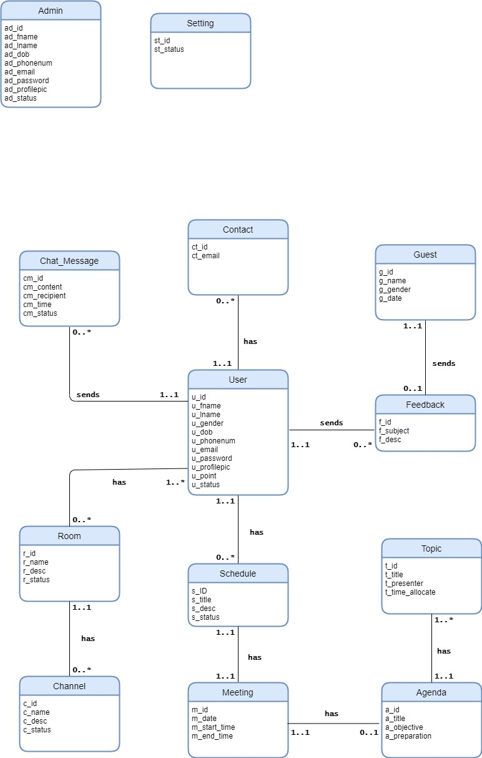

Figure 4.2: Conceptual Entity Relationship Diagram

The ER diagram for video conferencing system contains 11 tables.

Table 4.2: Description of ER Diagram

|  |  |  |  |
| --- | --- | --- | --- |
| **Table Name** | **Description** | **Attribute** | **Data Type and Length** |
| user | contains the information for every user | u_id  u_fname  u_lname  u_gender  u_dob  u_phonenum  u_email  u_password  u_profilepic  u_point  u_status | 10 numbers  30 variable characters  30 variable characters  1 character (M/F)  Date  11 variable characters  30 variable characters  30 variable characters  BLOB  10 numbers  1 character (A/I) |
| guest | contains the information for every guest | g_id  g_name  g_gender  g_date | 10 numbers  30 variable characters  1 character (F/M)  Date |
| room | contains the information for every meeting room. | r_id  r_name  r_desc | 10 numbers  30 variable characters  Text |
| channel | contains the information for every channel. | c_id  c_name  c_desc | 10 numbers  30 variable characters  Text |
| schedule | contain the information for meeting schedule. | s_id  s_title  s_desc | 10 numbers  30 variable characters  Text |
| meeting | contain the information for a meeting. | m_id  m_date  m_start_time  m_end_time | 10 numbers  date  time  time |
| agenda | contain the information for a meeting agenda. | a_id  a_title  a_objective  a_preparation | 10 numbers  30 variable characters  100 variable characters  100 variable characters |
| topic | Contain the information for a topic | t_id  t_topic  t_presenter  t_duration | 10 numbers  50 variable characters  30 variable characters  time |
| contact | contain the information for a contact. | ct_id  ct_email | 10 numbers  30 variable characters |
| chat_message | contain the information for a chat message. | cm_id  cm_recipient  cm_datetime  cm_status | 10 numbers  30 variable characters  datetime  10 variable characters (R/U) |
| feedback | Contains the feedback send by users and guest | f_id  f_subject  f_desc | 10 numbers  30 variable characters  text |

Table 4.3: Description of Relationship in ER diagram

|  |  |  |  |  |
| --- | --- | --- | --- | --- |
| **Entity Name** | **Multiplicity** | **Relationship** | **Entity Name** | **Multiplicity** |
| user | 1..1  1..1  1..1  1..*  1..1 | has  sends  sends  has  has | contact  chat_message  feedback  room  schedule | 0..*  0..*  0..*  0..*  0..* |
| guest | 1..1 | sends | feedback | 0..1 |
| schedule | 0..* | belongs to | user | 1..* |
| meeting | 1..1 | has | agenda | 0..1 |
| agenda | 0..1  1..1 | belongs to  has | meeting  topic | 1..1  1..* |
| topic | 1..* | belongs to | agenda | 1..1 |
| contact | 0..* | belongs to | user | 1..1 |
| chat_message | 0..* | sends by | user | 1..1 |
| room | 0..*  1..1 | belongs to  has | user  channel | 1..*  1..* |
| channel | 1..* | belongs to | room | 1..1 |
| feedback | 0..*  0..1 | sends by  sends by | user  guest | 1..1  1..1 |

### User Interface Prototype

#### Low Fidelity User Interface Prototype

When the user first enters the web application, the application will show a login form. If the user has a registered account, then he can an enter email address and password to sign in. If the user does not have an account, but he has an invitation link, then he can enter the invitation link to join a meeting. If the user does not have an account and an invitation link, he must click the “sign up” button to register a new account.

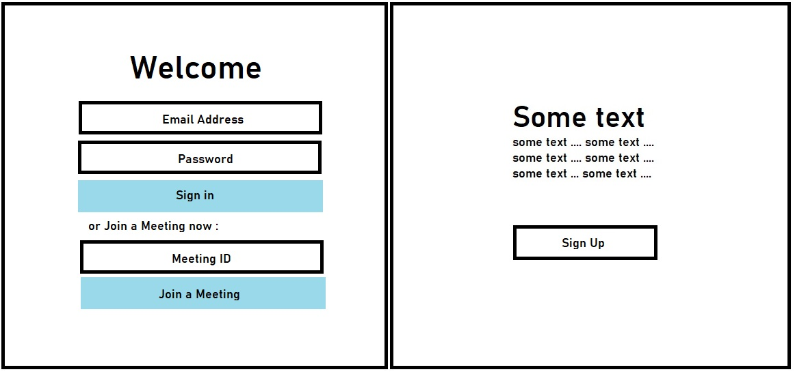

Figure 4.3: Sign In Page

To register a new account, the user needs to enter all the personal data and click on the sign-up button. The system will show a message indicate that the user creates an account successfully. Then the user needs to sign in.

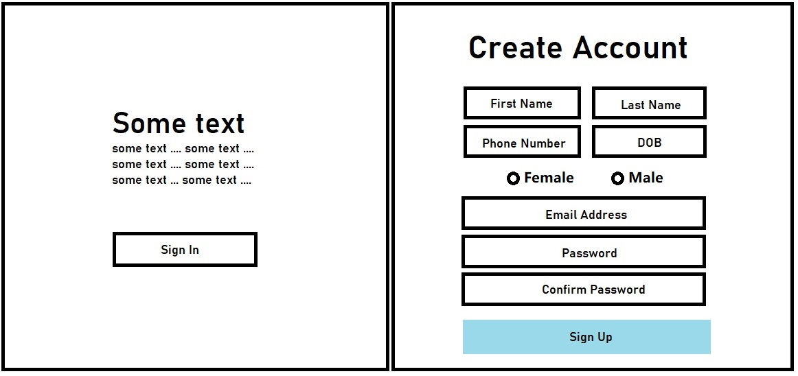

Figure 4.4: Sign Up Page

Every page has a side navigation bar on the left.

Table 4.4: Navigation Bar and Descriptions

|  |  |
| --- | --- |
|  | If the user wants to view the main page, select the first button.  If the user wants to view the contact list, select the second button.  If the user wants to view the notification, select the third button.  If the user wants to view the text message, select the fourth button.  If the user wants to view the meeting schedule, select the fifth button.  If the user wants to change the setting, select the sixth button. |

When the user enters the main page, the application will show the room panel. It contains a search engine, add button and a list of room.

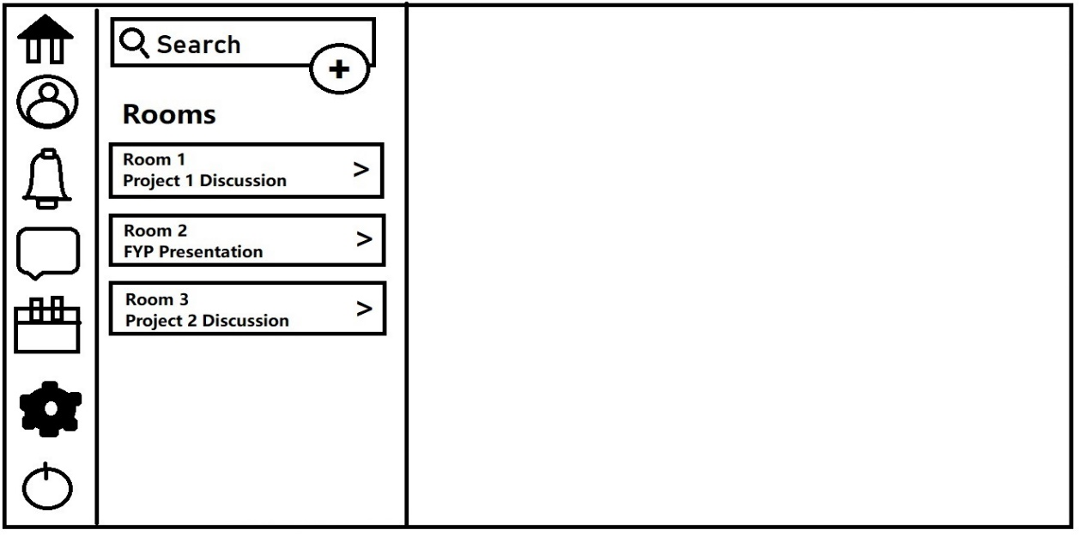

Figure 4.5: Main Page

To start a group meeting, a user needs to create a meeting room and a channel. To create a new room, the user can click the add button will pop out a form to create a room.

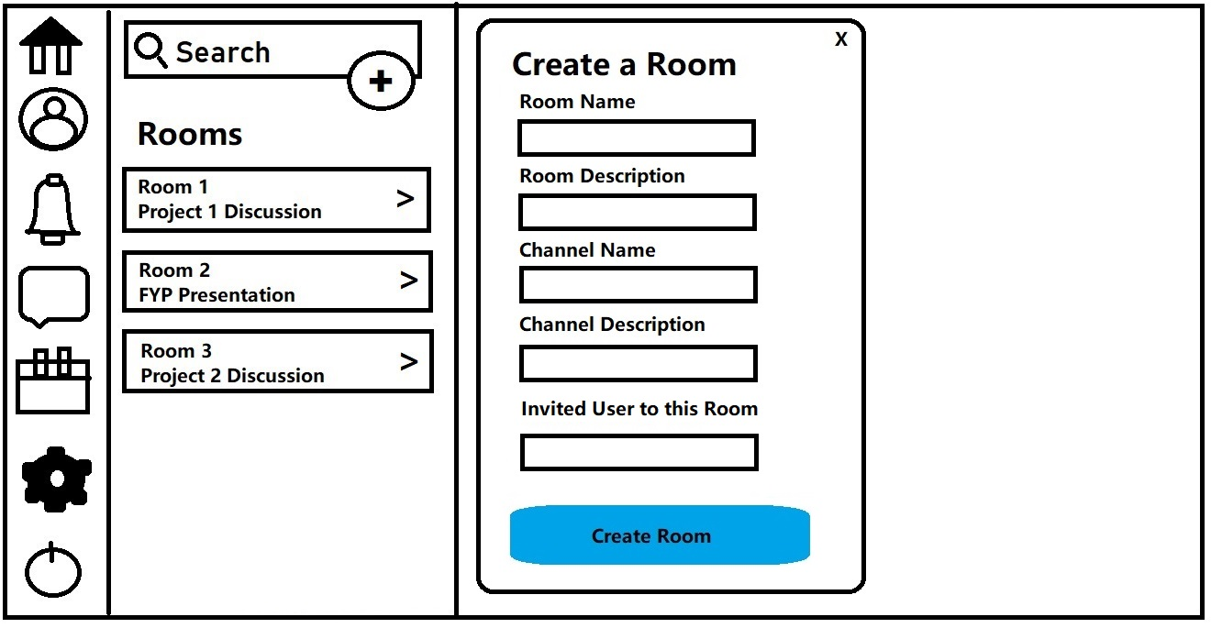

Figure 4.6: Create a Room

The user can click on a room to see the channel of the room.

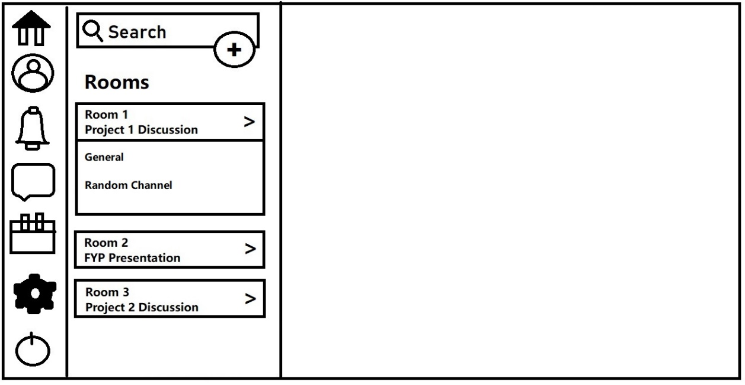

Figure 4.7: Channels of a Room

The user can click on the channel to enter the channel. The user can view the conversation in the channel. On the top right there are three buttons. The first button is to start an audio call, second is to start a video call while the third is setting. Besides, there is a participant list and a meeting agenda.

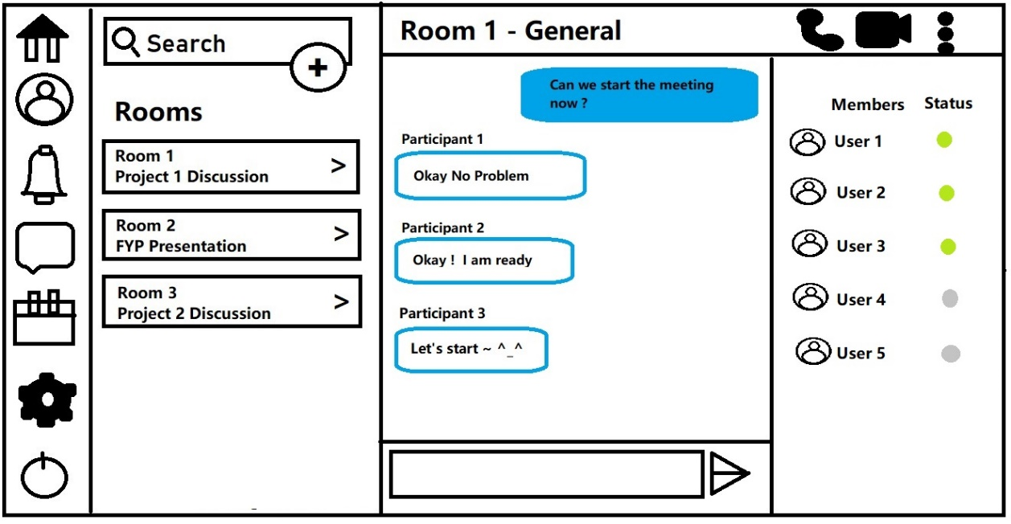

Figure 4.8: View on Channel

When the user clicks on the contacts button, the application will show the contact list panel. It contains a search engine, add button, three filer buttons (All, Online, Offline) and a list of contact with username and email. Beside each contact there is a delete button.

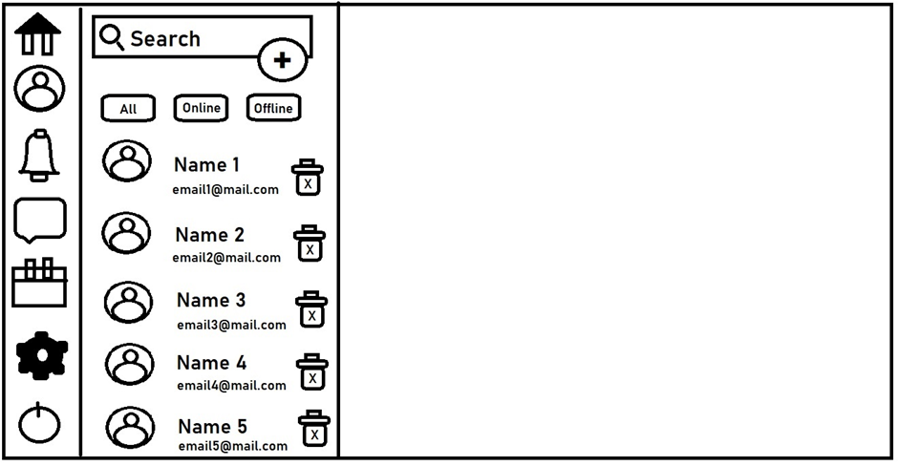

Figure 4.9: Contact List

If the user wants to add a contact, click the add button and a form will be shown. The user can search for a friend by entering a phone number or an email address. If the user wants to delete a contact, click the delete button.

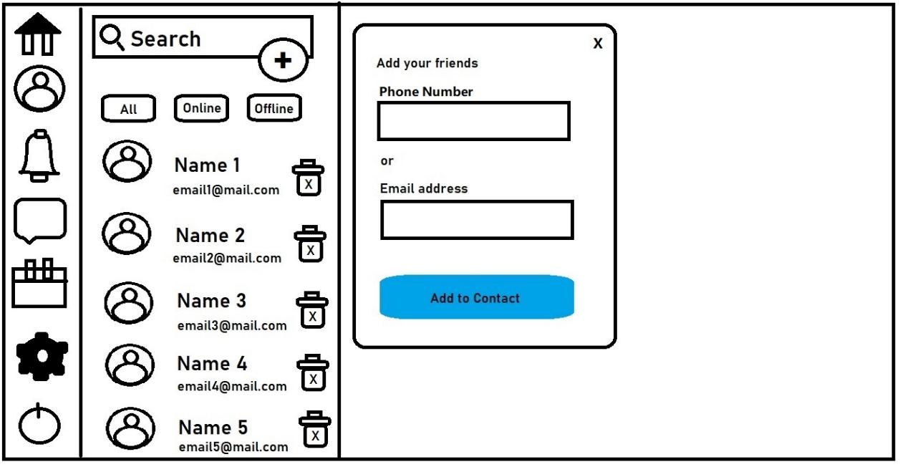

Figure 4.10: Add Friends

If the user wants to view the notification received, click on the notification button. The system will show a notification panel. It contains a search engine, three filer buttons (All, Latest, Oldest) and a list of notification.

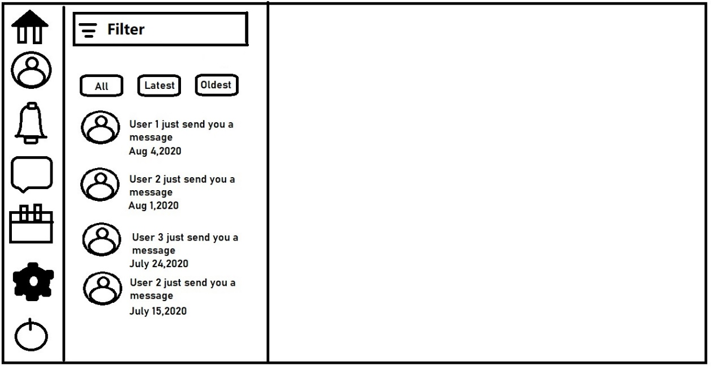

Figure 4.11: Notifications

If the user wants to view the chatbox, click on the chat button. The system will show the conversation panel. It contains a search engine, add button, three filter button (All, Read, Unread) and a list of conversation

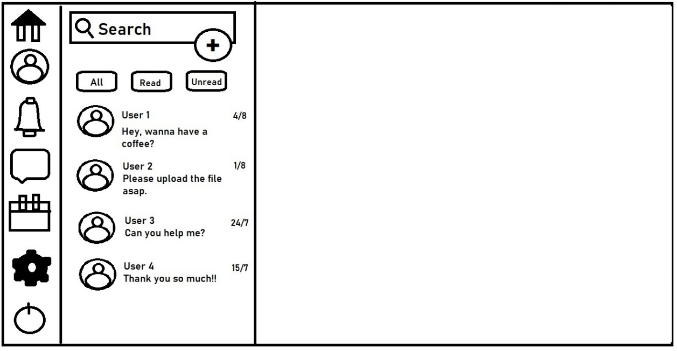

Figure 4.12: View of Chat Box Panel

The user can select on a conversation to see the whole conversation. On the top right there are three buttons. The first button is to start an audio call, second is to start a video call while the third is setting.

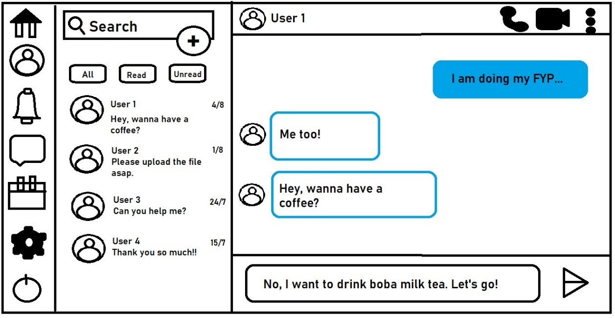

Figure 4.13: View of Conversation Window

If the user wants to send a chat message to a new recipient, select on the add button and the system will show a form. The user can enter the recipient and send a new message.

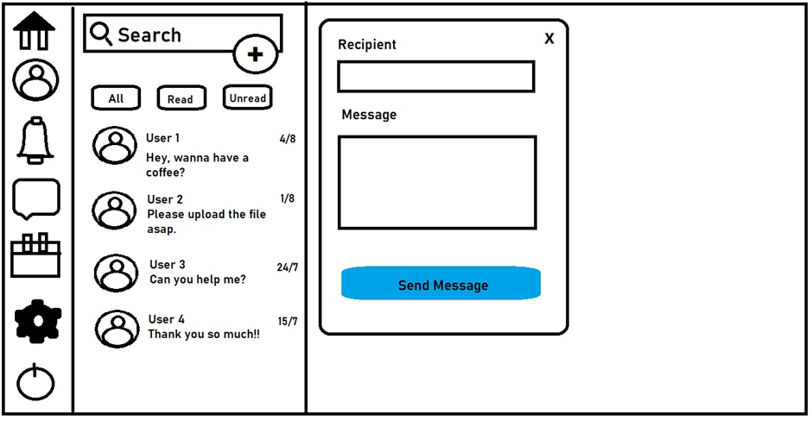

Figure 4.14: Creating a New Chat

If the user wants to view the meeting schedule, click on the schedule button. The system will show a schedule panel. It contains a search engine, add button, three filter buttons (All, Latest, Oldest) and a list of the meeting schedule.

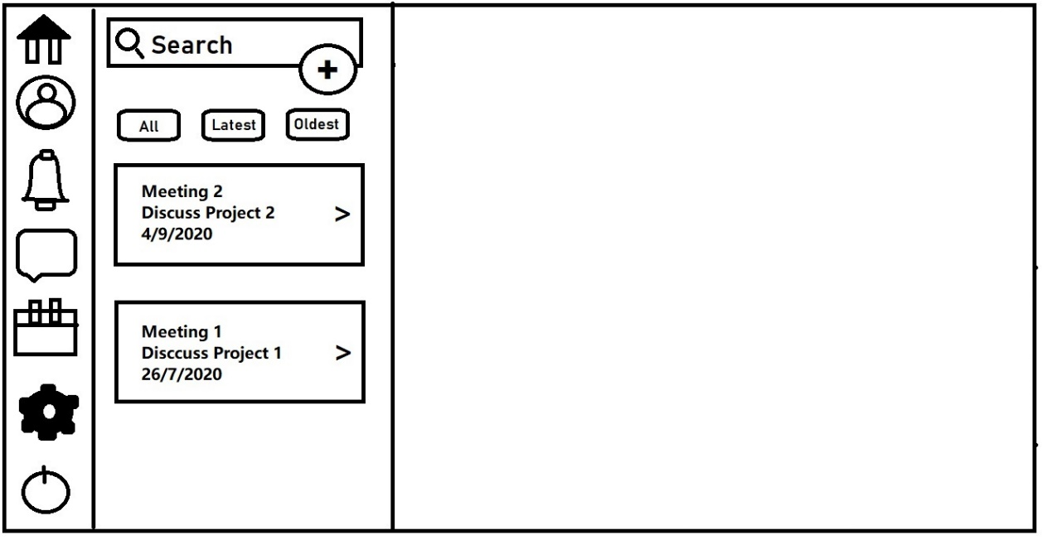

Figure 4.15: Overview of Meeting Schedule

The user can select on a meeting schedule to view and edit the meeting agenda.

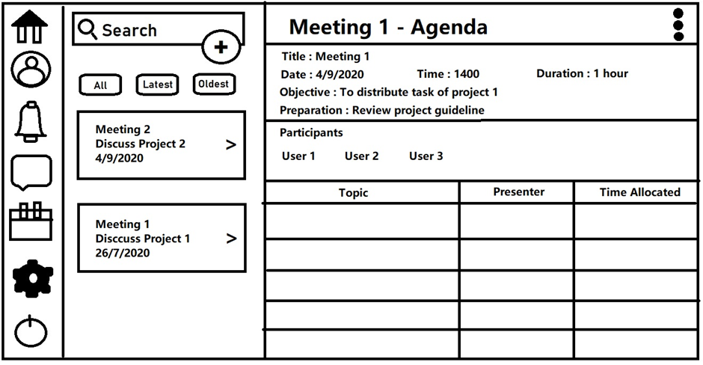

Figure 4.16: Details of Meeting Schedule

If the user wants to create a new schedule, click the create button and the system will show an add schedule form.

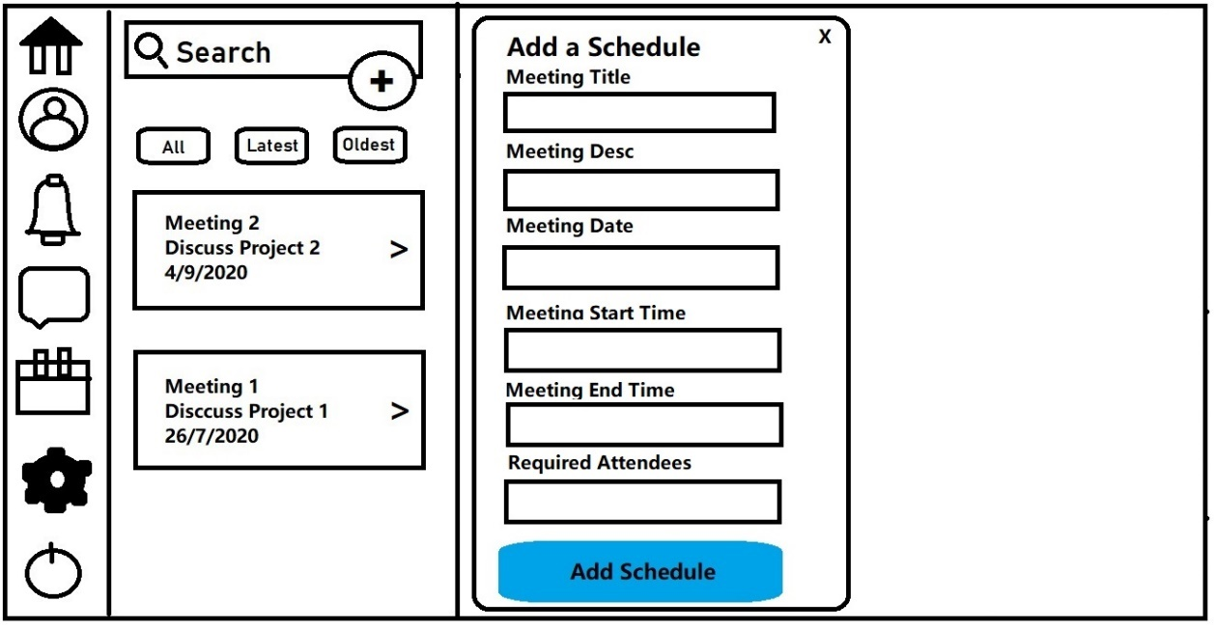

Figure 4.17: Add a Schedule

If the user wants to manage his profile and edit the setting, click on the setting button. The system will show a setting panel as shown in Figure 4.18. The systems will tell user the total number of contacts, the total number of room and the total points gained when joining a meeting. There are five buttons below the user information. The first button is My Account. It allows the user to upload profile picture and edit the personal details. The second button is Change Password. The user must enter the current password to change a new password. The third button is Notification. The user can also switch on or off the setting to receive system notification. The fourth button is Status. The user can change the visibility of the online status to another user or not. The fifth button is Speed Test. The user can start a speed test for the internet connection before a meeting. The result will show the ping, jitter, download and upload speed of the user internet connection as shown in Figure 4.19.

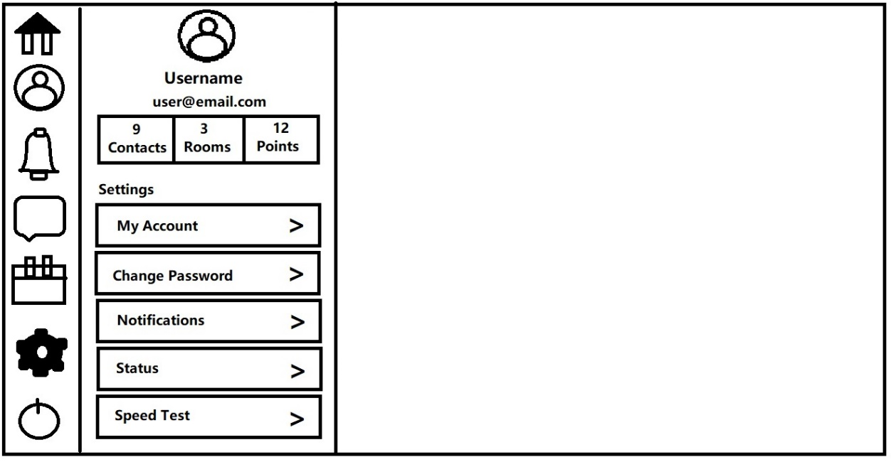

Figure 4.18: View of Account Setting

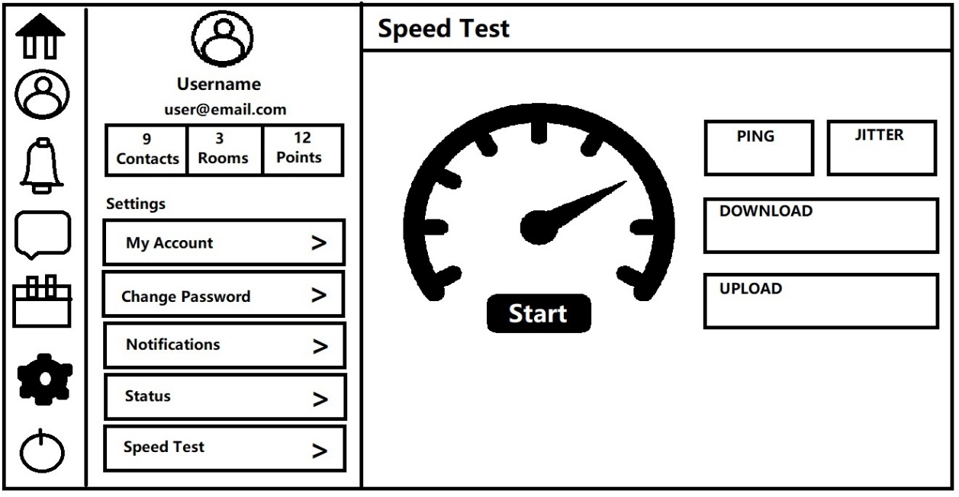

Figure 4.19 : View of Speed Test

#### High Fidelity User Interface Prototype

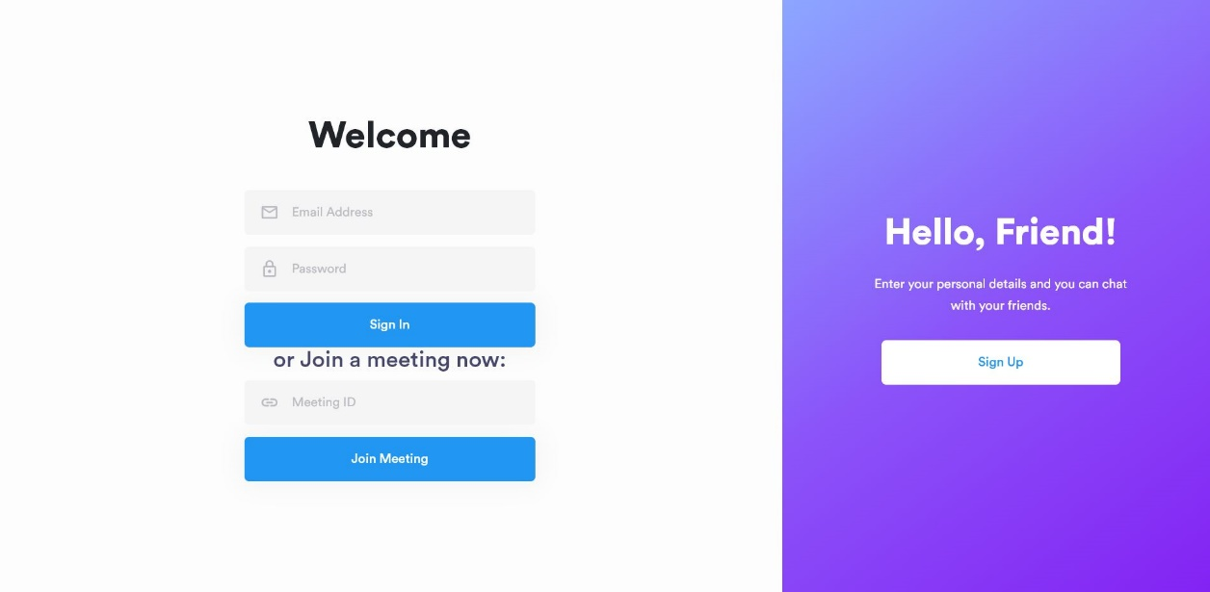

Figure 4.20: Sign In Page

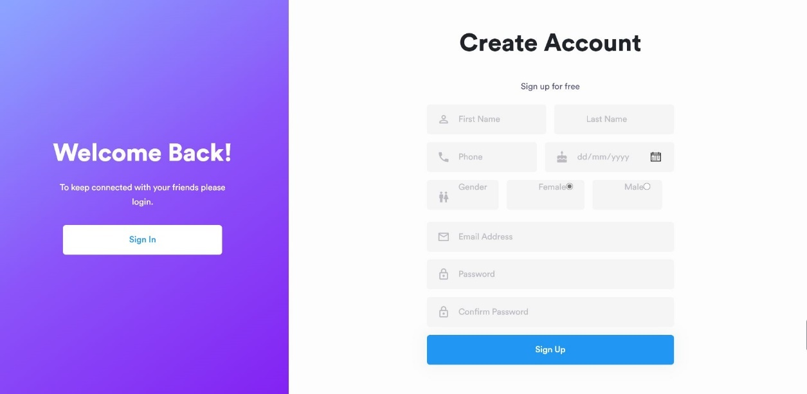

Figure 4.21: Sign Up Page

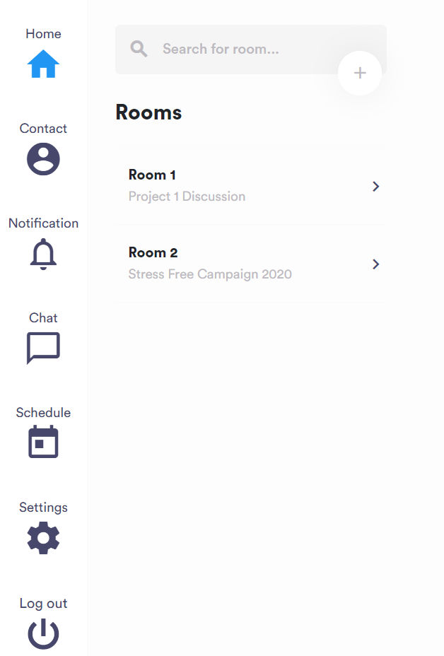

Figure 4.22: Home Panel

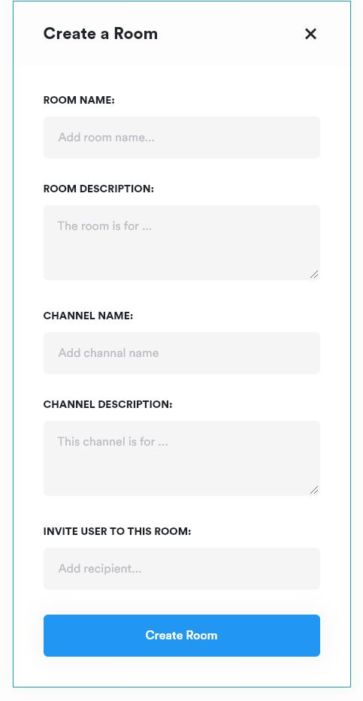

Figure 4.23: Create Room Form

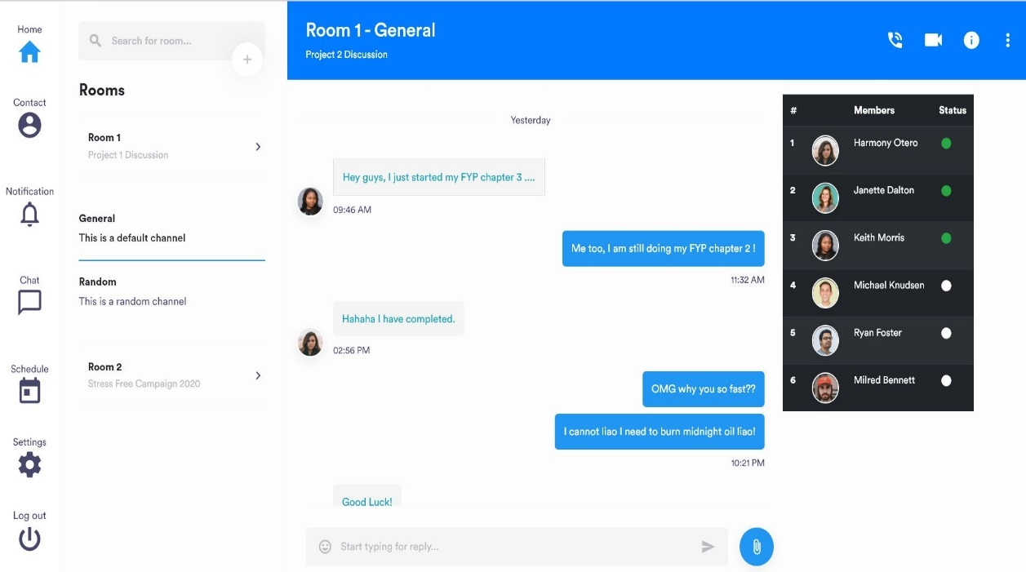

Figure 4.24: Group Conversation in a Meeting Room

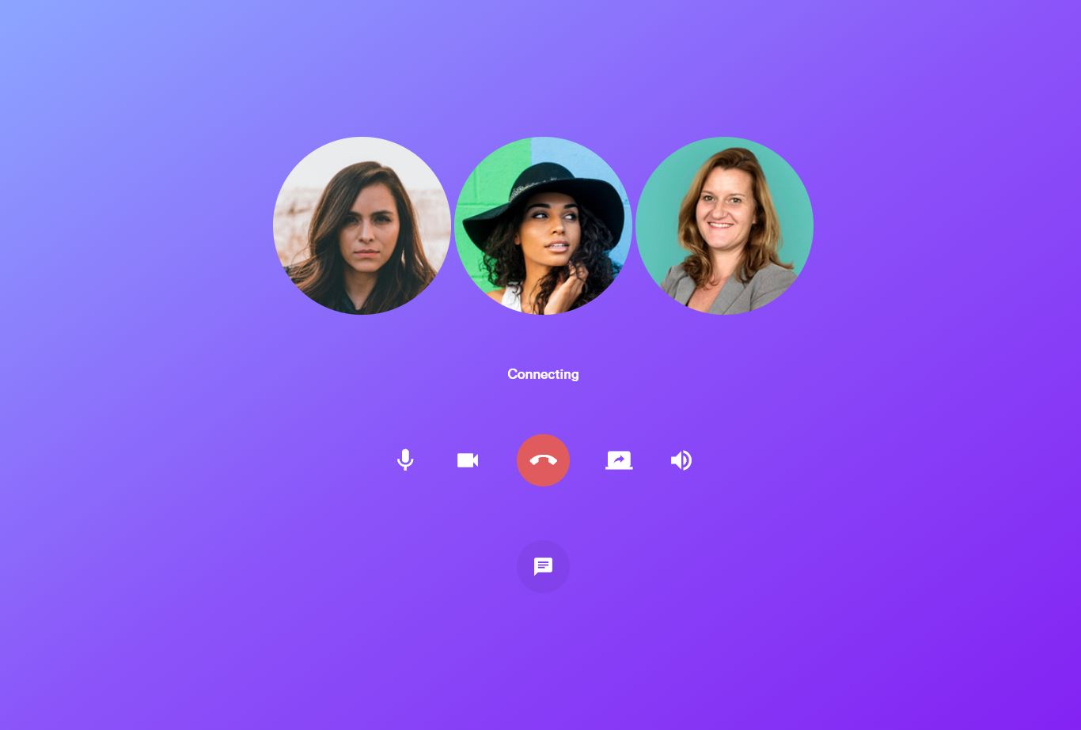

Figure 4.25: Calling to Multiple Users in a Room for Group Meeting

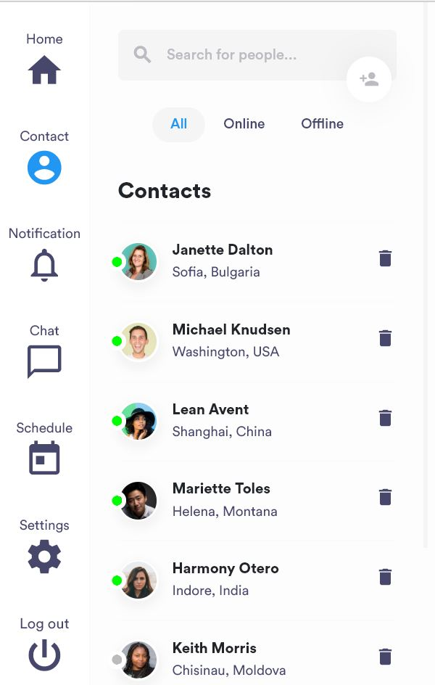

Figure 4.26: View of Contacts Panel

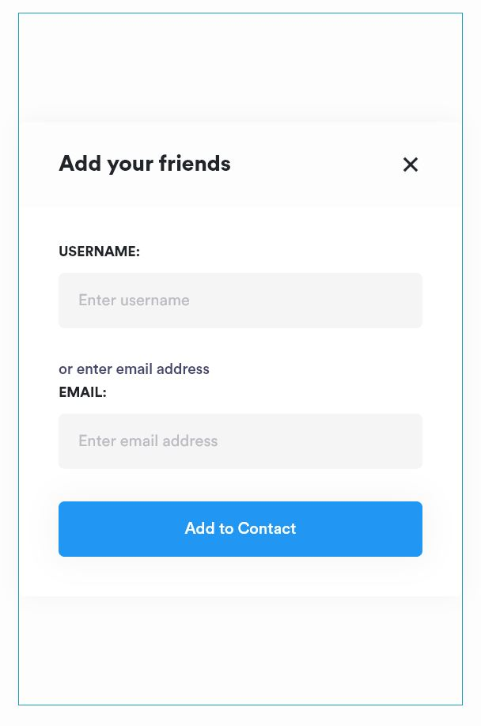

Figure 4.27: Add a New Contact

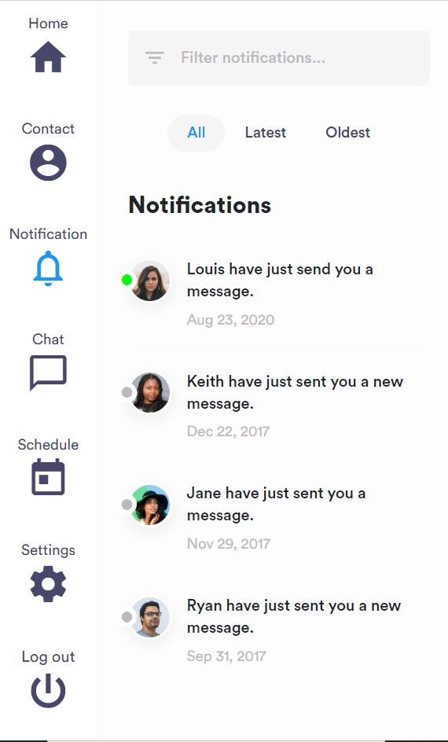

Figure 4.28: View of Notifications Panel

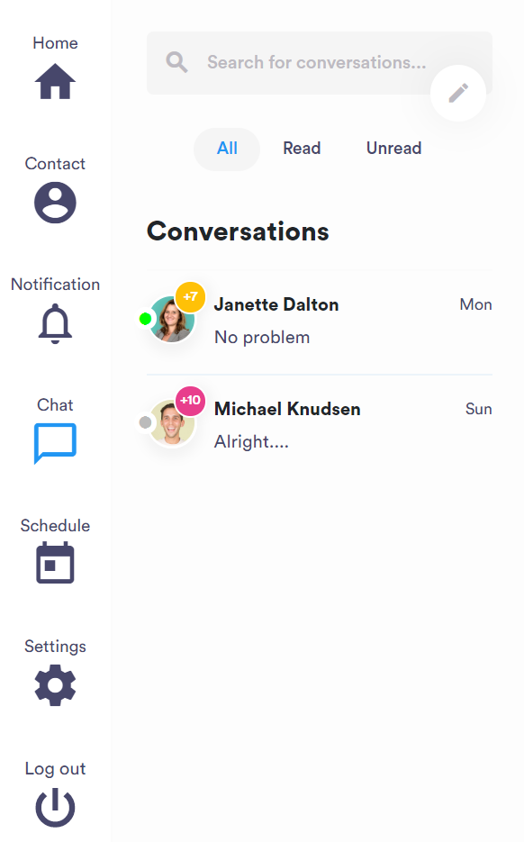

Figure 4.29: View of Chat Panel

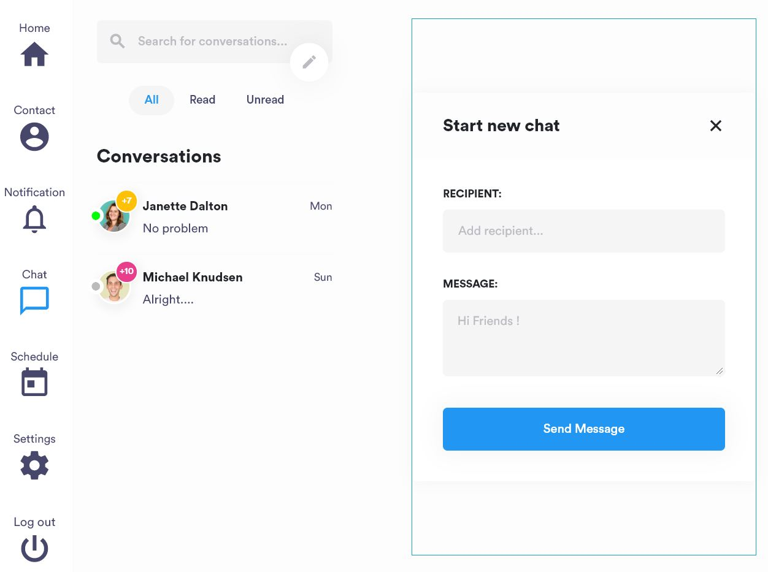

Figure 4.30: Send a New Message

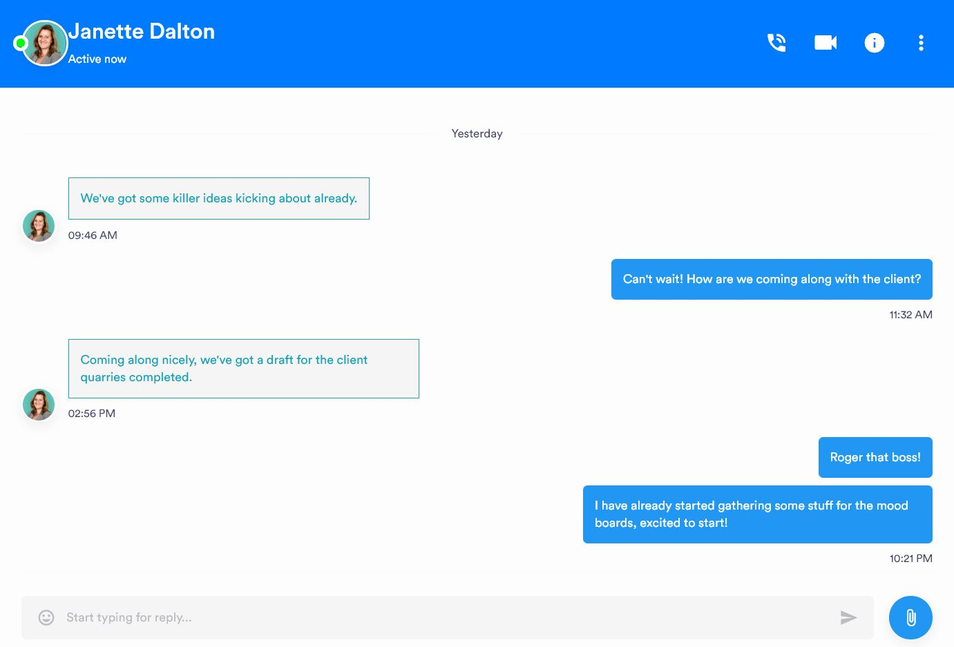

Figure 4.31: One-to-one Conversations

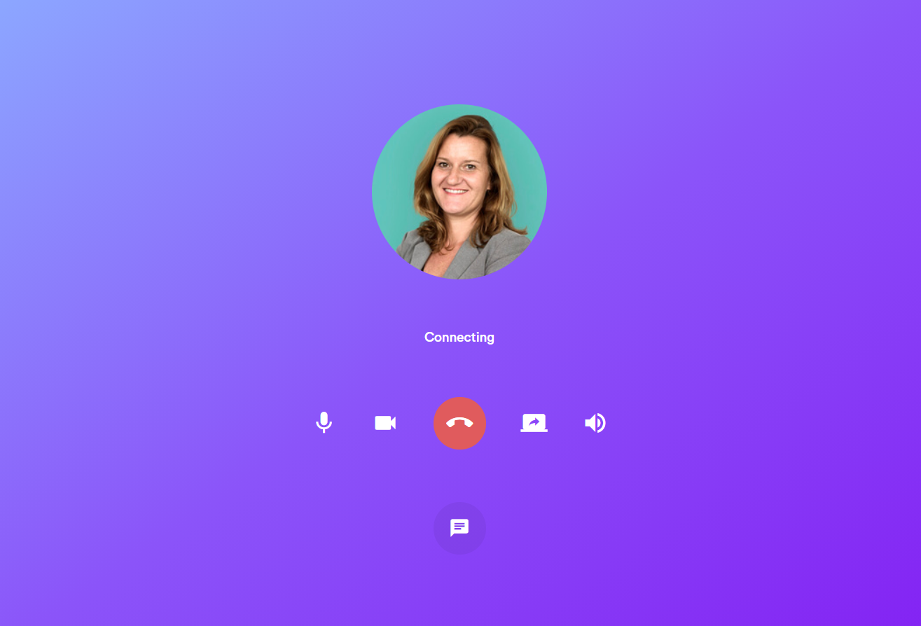

Figure 4.32: Calling to One User

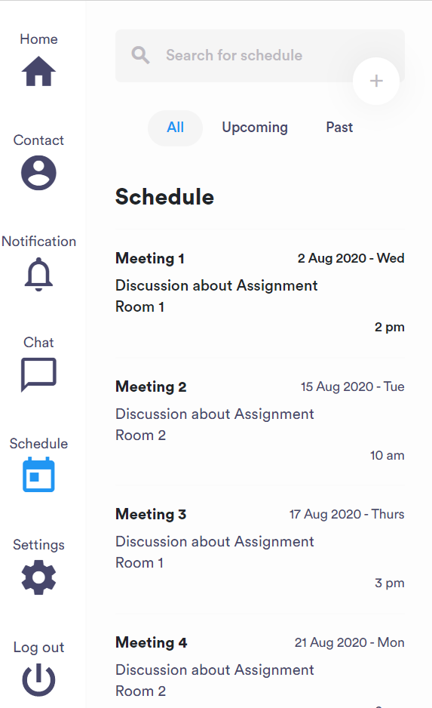

Figure 4.33: View of Schedule Panel

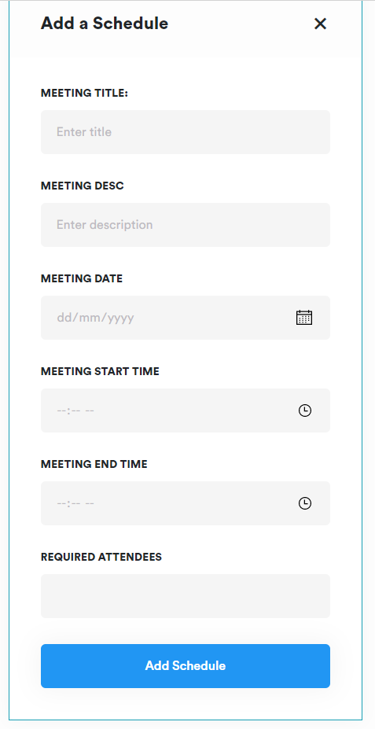

Figure 4.34: Add Schedule

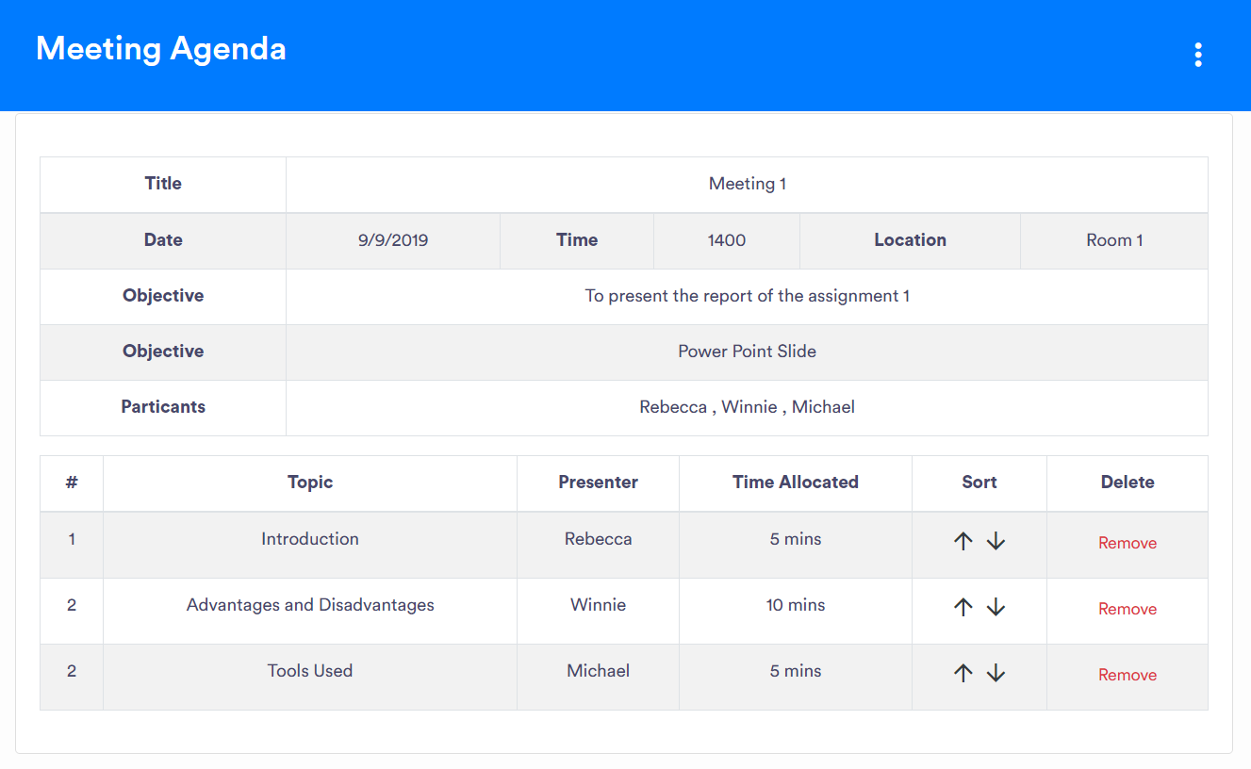

Figure 4.35: Meeting Agenda of a Scheduled Meeting

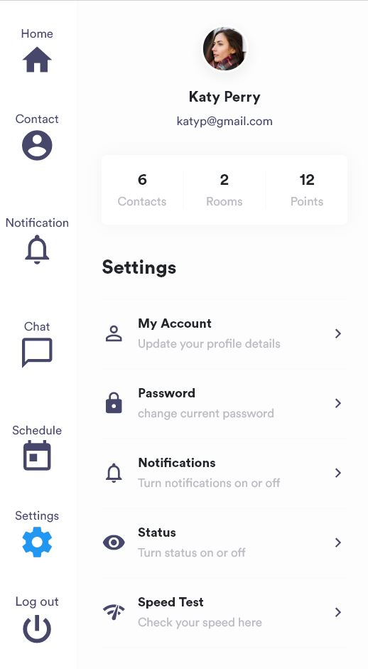

Figure 4.36: View of Settings Panel

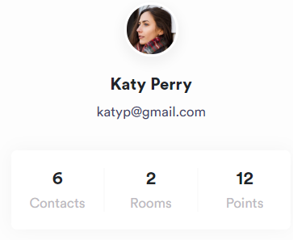

Figure 4.37: Account Info

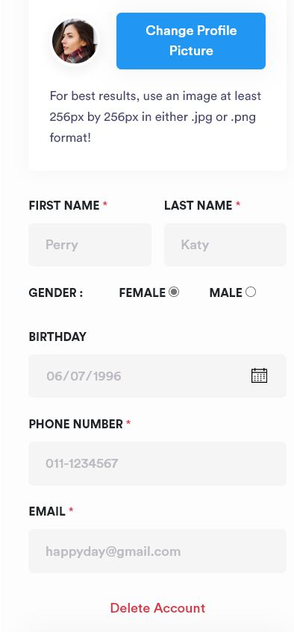

Figure 4.38: Edit User Profile

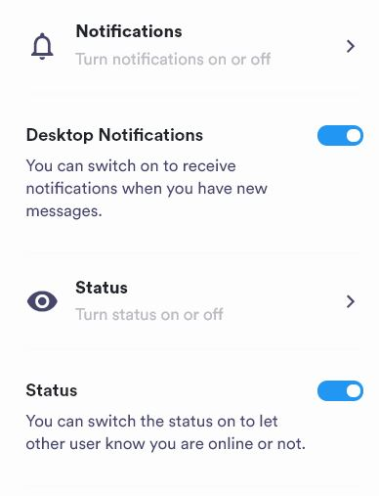

Figure 4.39: Notification and Status Settings

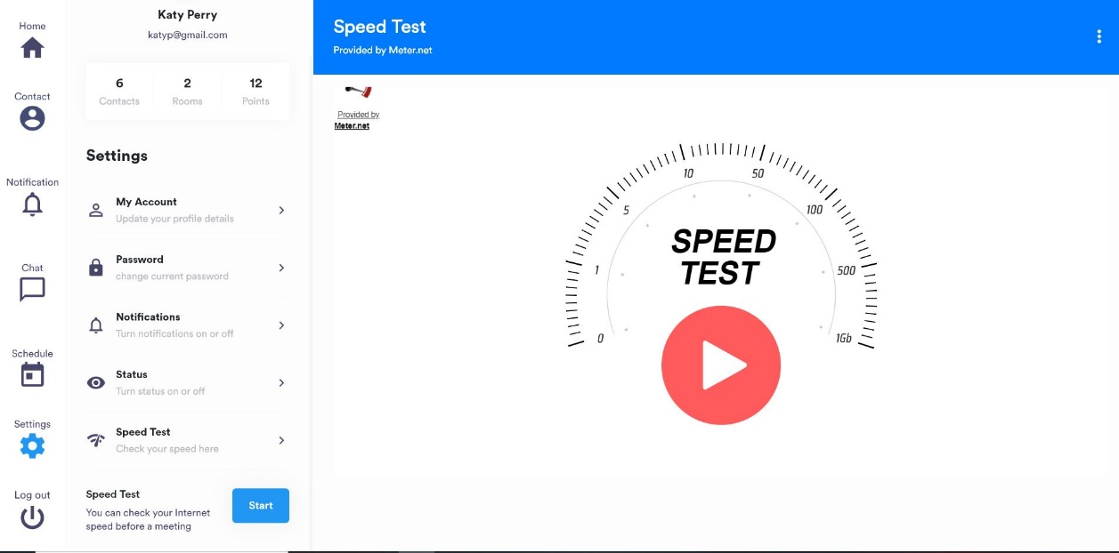

Figure 4.40: Start a Speed Test

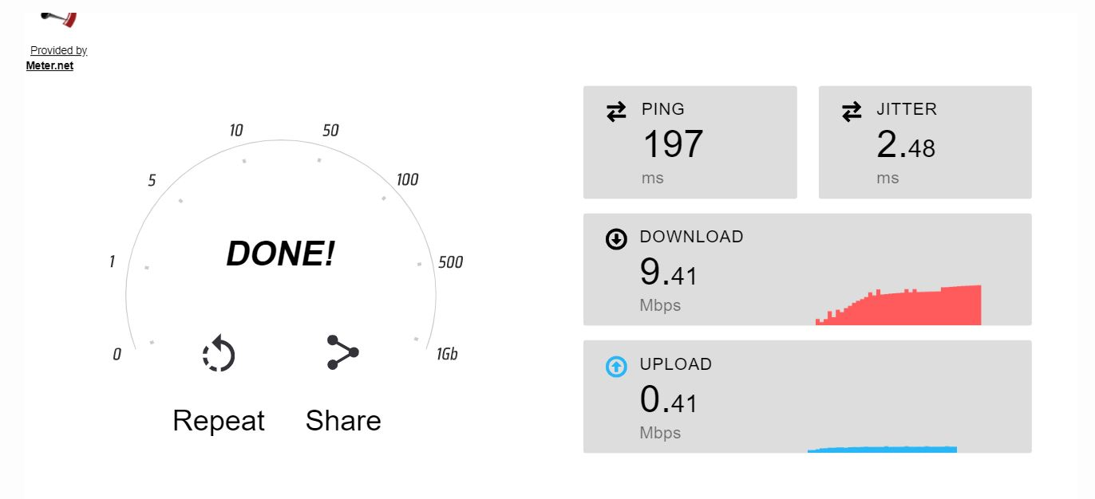

Figure 4.41 Speed Test Result

### Conclusion

This chapter shows the detailed functional and non-functional requirements. Besides, various design diagrams were produced in order to clarify the user requirements and to serve as a guide for the development process. Several design diagrams had been created for this web application included the use case diagrams with use case descriptions, conceptual ER diagram, and low and high-fidelity user interface designs.